A

Project Report On

**“**College Sports Department Management**”**

Designed By

Mr. Nikhil Kashinath Gosavi

Submitted To

K.M.S.P. MANDAL’S

SANT RAWOOL MAHARAJ MAHAVIDYALAYA, KUDAL.

(NAAC Accreditation “B” Grade)

**In the partial fulfillment of**

**B.Sc. Information Technology (Third year)**

Under Guidance of

**Prof. D. A. Patil (M.C.A.)**

Through

THE HEAD,

DEPARTMENT OF Information Technology,

S.R.M. COLLEGE, KUDAL.

**2016-2017**

**PROJECT REPORT**

**2016-2017**

**“**College Sports Department Management”

#### SUBMITED BY

**Mr. Gosavi Nikhil Kashinath**

**Seat No-**

#### GUIDED BY

**Prof. D. A. Patil (M.C.A.)**

##### **B. Sc. Information Technology**

**DEPARTMENT OF INFORMATION TECHNOLOGY,**

###### **K.M.S.P. MANDAL’S**

**S. R. M. Mahavidyalaya, Kudal.**



K.M.S.P. MANDAL’S

SANT RAWOOL MAHARAJ MAHAVIDYALAYA, KUDAL.

(NAAC Accreditation “B” Grade)

CERTIFICATE

This is to certify that **Mr. Gosavi Nikhil Kashinath** No. (**0000000)** have satisfactorily carried out his project work entitled.

**“College Sports Department management”**

As per the syllabus prescribed for T. Y. B.Sc. (Information Technology) of **Mumbai University, Mumbai**.

It is also certify that this is him own work completed during academic year 2016– 2017. The work done is satisfactory and is presented as per the specifications.

**PROJECT GUIDE EXTERNAL EXAMINIER HEAD OF DEPARTMENT**

**DATE:**

**PLACE:** KUDAL.

**DECLARATION**

To,

THE HEAD,

DEPARTMENT OF INFORMATION TECHNOLOGY,

S. R. M. COLLEGE, KUDAL.

Respected Sir,

I undersigned, hereby declare that the project on **College Sports Department Management** is developed under the guidance of our lecturer Prof. D. A. Patil.

The conclusion in this report is based on the data, which is collected by me. I am declaring that this is my original work. I have not copied any materials, which are useful to my work, or other reports that are submitted to the S.R.M.COLLEGE, KUDAL this year.

I do undersign that if my work is found to be copied, then I am liable to punishment as per the university rule.

**DATE :**

**PLACE** : KUDAL. (Mr. Gosavi Nikhil Kashinath)

**ACKNOWLEDGEMENT**

Many people have helped during my project and each of their contribution has been valuable. The timely completion of this project is mainly due to the interest and worth helping of His/her help will be remembered forever.

I would like to thank Asst. Prof. D. A. Patil, Prof. P. S. Kerawdekar and

Asst. Prof. Miss P. R. Rane for Guide me during my project work. I want to acknowledge the principal of “**SRM College, Kudal**” for giving me the information about the manual system of the college and thanks to the all faculty of the college

Also thanks of my all friends who help me during my project. Finally, I wish to thank Asst. Prof. S. G. Patil for providing important help.

Thank You

(Mr. Gosavi Nikhil Kashinath)

**PREFACE**

This project is my maiden effort to prepare the College Sports Department Management. This project has been designed under WINDOWS 7(Ultimate) operating system at Department of Information Technology, S.R.M. College, Kudal for the “Sports Department Management” Which would be more efficient.

This report presents detailed description of my project

**INDEX**

|  |  |  |  |
| --- | --- | --- | --- |
| **Sr.No.** | **Chapter.No.** | **TITLE** | **Page No.** |
| **1** |  | **Investigation** |  |
|  | **I.** | Organization Overview | 10 |
|  | **II.** | Objective And Scope of Project | 11 |
|  | **III.** | Limitations With Existing System | 12 |
|  | **IV.** | Advantage Of Proposed System | 13 |
|  | **V.** | Feasibility Study | 14 |
|  | **VI.** | Cost Benefit Analysis | 15 |
|  | **VII.** | Detailed Life Cycle Of Project | 16 |
| **2** |  | **Analysis** |  |
|  | **I.** | Description of System | 19 |
|  | **II.** | Stakeholders | 20 |
|  | **III.** | Requirement Gathering | 21 |
|  | **IV.** | Requirement Specification | 23 |
|  | **V.** | Tools & Technology | 25 |
|  | **VI.** | Schedule | 26 |
|  | **VII.** | Gantt Chart | 27 |
| **3** |  | **System Design** |  |
|  | **I.** | Event Table | 29 |
|  | **II.** | Use Case Diagram | 31 |
|  | **III.** | E-R Diagram | 35 |
|  | **IV.** | Activity Diagram | 37 |
|  | **V.** | Class Diagram | 40 |
|  | **VI.** | Sequence Diagram | 43 |
|  | **VII** | Object Diagram | 45 |
|  | **VIII.** | State Diagram | 47 |
| **4** |  | **System Coding** |  |
|  | **I.** | Data base Design | 50 |
|  | **II.** | Component Diagram | 54 |
|  | **III.** | Site Map | 56 |
|  | **IV.** | Forms Design | 59 |
|  | **V.** | Program Listing | 69 |
|  | **VI.** | Form Module Coding | 70 |
|  | **VII.** | Validating Forms | 80 |
| **5** |  | **Testing** |  |
|  | **I.** | Module Testing/ unit testing | 84 |
|  | **II.** | Integration Testing | 84 |
|  | **III.** | System Testing | 84 |
|  | **IV.** | Test Case Specification | 87 |
| **6** |  | **System Implementation** |  |
|  | **I.** | Deployment Diagram | 89 |
|  | **II.** | System Implementation | 90 |
|  | **III.** | URL | 91 |
| **7** |  | **System Maintenance and evaluation** |  |
|  | **I.** | System Maintenance And Future Enhancement | 93 |
|  | **II.** | User Manual/ help report | 94 |
| **8** |  | **References and Bibliography** |  |
|  | **I.** | References and Bibliography | 100 |

**CHAPTER I**

**SYSTEM INVESTIGATION**

**ORGANIZATIONAL OVERVIEW**

**Name of Organization: -**SRM COLLEGE, KUDAL

**Address: -** A.P-Kudal, Tal-Kudal,

Dist- Sindhudurg,

PIN- 416520

**Contact No**:- 02362(222242)

**About Organization:-**

The College’s Sport Department is a department which manages the information of the students and competitions related to sports department. Taking into consideration the need for computers today’s generation we choose to design a system that is more reliable & user friendly than the manual system which is being implemented.

**OBJECTIVE AND SCOPE**

Objective of my project is to make the current manual system into computerized system which will be more effective to use. The Register System is time consuming and complicated.

The main objective of this system is to design and develop a user friendly, easy to use and efficient “College Sports Department Management”. Develop an accurate and reliable system. Computerization can be helpful in meeting increased workload.

This system is to reduce the lot of paperwork needed to generate the reports and also to generate maximum reports in less time.

So this new system will reduce the paper work and also reduce manual work which ultimately require less time. So the entire process will become faster.

**LIMITATIONS OF PRESENT SYSTEM**

* **More Paper Work:-**

The present system uses the more papers for storing the data of students because in present system it should be in hard copy.

* **Time Consumption:-**

The whole work is done manually which is time consuming.

* **Large Amount of Efforts:-**

Maintaining and searching of all records takes lot of efforts.

* **Less secure:-**

All records are maintain in the hand written book(Register) or on paper therefore, The data is not secure. Anyone can misuse the data.

* **Loss of Information:-**

The daily, monthly & yearly records which are done manually are not easily to maintain in the file or registers which can be destroyed any time by any person.

**PROPOSED SYSTEM & IT’S ADVANTAGES**

The use of newly proposed system is computerized data entry & information retrieval. The data is stored in database. The security provided by this newly computerized system will be much higher than the existing system. Student registers to the system and Admin will approve them. The notice will be uploaded by Admin and displayed to Student. Student will view notice and apply for competition and Admin will approve them.

**Advantages:-**

* This system reduces human efforts.
* The records are permanently stored in database, it is more secured.
* System maintains records in efficient manner.
* Quickly analyzing and searching of data.
* All transactions perform by a computer. So there is not risk to loss the information.
* There is not wasting of time.
* We can store the information for long time.

**FEASIBILITY STUDY**

When a project is initiated, it is assumed that a new system is feasible to develop & install.

* **Economic feasibility:-**

A determination of economic feasibility of a project always requires a through cost benefit analysis. In that we can estimate the cost using SLOC Technique.

The development of the College Sports Department Management is feasible economically because this system is affordable for both clients as well as for developers.

* **Organizational & Cultural feasibility:-**

There is always the risk that the new system may depart so dramatically from existing norms that can’t be successfully deployed. Define user manual to deploy the softwares on client-side.

* **Technological feasibility:-**

A new system brings new technology into a company. At times the new system stretches the state of the art of the technology. Choose Latest Technology and Tool.

The development team is able to work on new technology so this is also feasible.

* **Schedule feasibility:-**

The development of project within given time is feasible for development team. Also the schedule is prepared to complete the project on-time. Hence, the schedule feasibility is feasible.

* **Resource feasibility:-**

The project management team must assess the availability of resource for the project. We can perform proper utilization of resources.

For the system the development team requires some resources so developers are able to manage that so this is also feasible.

**COST BENEFIT ANALYSIS**

My project has following major functionalities:-

* Save
* Update
* Delete
* Report

For Save button I have written 20 lines of code per form. I have 21 forms in my project. So total line of code for save functionality is 420 lines.

For Save button with Image I have written 30 lines of code per form. I have 6 forms in my project. So total line of code for save functionality is 180 lines.

For Update button I have written 15 lines of code per form. I have 18 forms in my project. So total line of code for Update functionality is 270 lines.

For Delete button I have written 14 lines of code per form. I have 19 forms in my project. So total line of code for Delete functionality is 266 lines.

For Reporting I have written 25 lines of code per form. I have 5 forms in my project. So total line of code for Delete functionality is 125 lines.

Along with this there are number of lines of code written for validation. So the total numbers of lines of code are near about 2500.

The cost per line of code is approximately Rupees10. So the total cost estimated is 25000.

**DETAILED LIFE CYCLE OF PROJECT**

I will follow Waterfall Model for developing this system.

**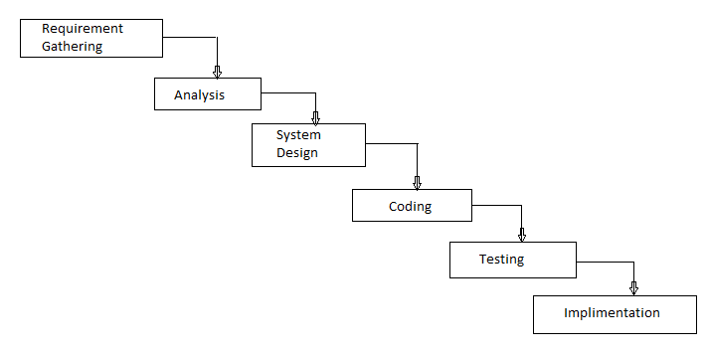**

**WATERFALL MODEL:-**

The **waterfall model** is a sequential [design](http://en.wikipedia.org/wiki/Design) process, often used in [software development processes](http://en.wikipedia.org/wiki/Software_development_process), in which progress is seen as flowing steadily downwards (like a [waterfall](http://en.wikipedia.org/wiki/Waterfall)) through the phases of Conception, Initiation, [Analysis](http://en.wikipedia.org/wiki/Analysis), [Design](http://en.wikipedia.org/wiki/Software_design), Construction, [Testing](http://en.wikipedia.org/wiki/Software_testing), Production/Implementation, and Maintenance. The phases in the waterfall model in software engineering are looked upon as separate process in itself. We cannot go back in phases.

**Requirement Gathering and Analysis Phase :**

This is the first phase in the waterfall software development model. In this phase the all the requirements from the user are captured. Analysis of the requirements is carried out to find out the possibility and validity of the requirements, which helps in assessing if the requirements can be incorporated in the system.

###### **Design Phase:**

This is one of the important waterfall model phases. In this phase the software to be developed is designed. The specifications of the system are taken into consideration and on the basis of the study of the specification the system design is made. Along with the software requirements, the hardware requirements and the other system requirements are also decided in this phase. In short the entire system architecture is chalked out.

###### **Coding Phase :**

###### In this phase the source line of code is written to meet the design requirements . Coding of system is done in this phase. Small Modules are created, and these modules are used to build system by integrating them.

###### **Testing Phase :**

The next phase in the waterfall model diagram is the implementation phase. In this phase the actual software is developed. There is unit testing carried out after the particular module has been developed as well. Carrying out the tests in this phase often proves to be beneficial, as the problems in the system are identified early into the software development phase.

###### **Implementation Phase:**

After user acceptance test is over the next phase is to deploy the system to the client side. Maintenance of the system is also part of a Implementation Phase.

**Advantages:**

1. It defines very first software development process.
2. It always produces a good quality product in terms of space and time.

**Disadvantages:**

1. Naturally project require more time.
2. Customer should have patience.
3. Time required for each phase cannot be predicted.

**CHAPTER II**

**SYSTEM ANALYSIS**

**DESCRIPTION OF SYSTEM**

* **Principle of the college : -**Dr. S. D. Disale.
* **History :-** Established on 25th June 1984.
* **No of Teachers :-** 32
* **No of Departments:-** 13
* **Student-Teacher Ratio:-** 31:1
* **Contact Number:-** 02362(222242)
* **Email address:-** srmcollege@rediffmail.com

**STAKEHOLDERS**

Stakeholders are all people who have an interest in the successful implementation of the system.

**Users of Stakeholders:-**

* **Business Users: -**Business users are the people who use the system to perform the day-to-day operation.
* **Information Users :-** A information user is a person who needs current information from the system.
* **Management Users: -** Management will help an analyst answer any types of questions.
* **Client Stakeholders: -** Clients may be a separate group, such as a board of thrusters or executives in parent company.
* **Technical Stakeholders: -** The technical staff includes people who establish & maintain the computing environment of the organization.
* **Stakeholders of the proposed system:-**
* Principal of the college
* Members of the NAAC
* Committee members
* HOD of all departments
* Teachers
* Management faculty
* Developer.
* Tester

**REQUIREMENT GATHERING**

To study the system we require facts (information). Fact is also termed as data (processed information). The specific methods used for collecting data are called fact finding technique.

Interview, questioner, record review, observation are the different fact finding techniques.

1. **Interview :-**

It is used to collect information from individual or from group. The interviewer must plan in advanced and should know the problem under the consideration.

There are two types of interview-

1. Structured Interview
2. Unstructured Interview
3. **Structured Interview :-**

In this type of technique fixed type of questions are asked and that question covered in specific area. In this type of technique interview period may be short.

1. **Unstructured Interview :-**

In this type of technique different type of questions are asked and there are specify specific area. In this type of fact finding technique extra information may be collected.

1. **Questionnaires :-**

Questionnaires contain sequence of questions. It is used elicit information from large no. of persons. Questionnaires may be used as supplement to interview.

There are also two types of questions which are used for developing Questionnaires.

1. Open-ended Question
2. Close-ended Question

**i)Open-ended Question :-**

These are used to learn about opinion, filling and general experience about the problems.

**ii)Close-ended Question :-**

It contained specific question and response.

**Questionnaire:**

* What is the meaning of NAAC?
* What is the actual concept of NAAC?
* On which basis the NAAC give ranking to the college?
* What is the essential information required for the evaluation?
* How many departments are presents in your college?
* What is name of each department?
* How many teachers do work in each department?
* Where is main center of this factory?
* Who is the head of each department and what is their role?
* What are the main activities were conducted by the each of the departments?
* Who is the coordinator of those events?
* How many and what type of reports are generated?

**REQUIREMENT SPECIFICATION**

**Functional Requirement:-**

In [software engineering](http://en.wikipedia.org/wiki/Software_engineering) , a functional requirement defines a function of a [system](http://en.wikipedia.org/wiki/System) or its component. A function is described as a set of inputs, the behavior, and outputs.

**Functional Requirements are :**

* **R01 :**

By entering URL of System to browser the browser should display the NAAC website.

* **R02 :**

The Admin should be able to generate UserID automatically for Teacher to registration.

* **R03 :**

The intended Users (Admin/Teacher) are allow to login.

* **R04 :**

The All Users should fill their Details like Qualification, Publication, Patent, Research, Conferences, and so on.

* **R05 :**

Admin have access to their department information such as Student details, result details, activity details, and so on.

* **R06 :**

Admin should able to generate the report based on the information available or maintain in the system.

**Non-Functional Requirement:-**

A non-functional requirement is a [requirement](http://en.wikipedia.org/wiki/Requirement) that specifies criteria that can be used to judge the operation of a system, rather than specific behaviors.

Non-functional requirements are often called qualities of a system.

**Non-Functional Requirements are :**

* **Performance :**

Performance of the system must ne high means the insertion of data in database must be done quickly. Similarly update and delete functionality must run faster.

The time required to generate report must be less.

* **Security :**

This system should have separate areas for different roles such as administrator and employee. The login functionality must be available for the system, So no one from outside can login to the system.

* **Availability :**

System should be available for users (Admin or Teacher ) for all the time. There should not be down time in system.

* **Inter-Operability :**

The system should be accessible using maximum kind of browsers or client tool. All browsers should support the system.

**TOOLS AND TECHNOLOGY**

**Software Requirements :-**

Front End : Microsoft Visual Studio 2010

Back End : SQL Server 2008

Operating System : Windows 7

**Hardware Requirements :-**

Processor : Minimum Dual core

Memory : Minimum 2 GB of RAM

Storage device : 500 GB Hard disk space

**Tools:-**

Crystal Report Viewer or Microsoft Report Viewer

Star UML Tool

Microsoft Word

**SCHEDULE**

|  |  |  |  |
| --- | --- | --- | --- |
| **Sr.No** | **Contents** | **Proposed Date** | **Submission Date** |
| 1 | **Investigation** | **05/12/2016** | **19/12/2016** |
|  | Project fixing |
|  | Synopsis |
| 2 | **Analysis** | **20/12/2017** | **10/01/2017** |
|  | Requirement gathering |
|  | Objectives and scope of project |
|  | Problems with existing system |
|  | Advantages of proposed system |
|  | Feasibility study |
|  | Cost benefit analysis |
|  | Requirements specifications |
|  | Tools and technology |
| 3 | **Design phase** | **11/01/2017** | **31/01/2017** |
|  | Detailed life cycle of project(logic design) |
|  | Class diagram |
|  | ER diagram |
|  | Event table |
|  | Use case diagram |
| 4. | **Coding phase** | **01/02/2017** | **14/02/2017** |
|  | Database design(with proper records) |
|  | Forms |
|  | Modules designs |
|  | Validating forms/applications |
| 5 | **Testing phase** | **15/02/2017** | **22/02/2017** |
|  | Module testing/unit testing |
|  | Integration testing |
|  | System testing |
|  | Acceptance testing |
| 6 | **Maintenance and evaluation** | **23/02/2017** | **01/03/2017** |
|  | System maintenance and future enhancement |
|  | User manual/help report |

**GANTT CHART**

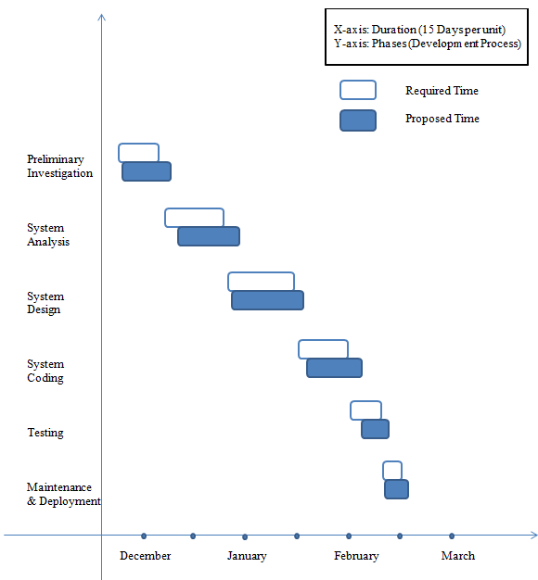

X-axis: Duration (15 Days per unit)

Y-axis: Phases (Development Process)

**CHAPTER – III**

**SYSTEM DESIGN**

**EVENT TABLE**

**Event Table: -**

Event table is a list of events of a system in rows and information about each event like.

1. **Trigger**–

An occurrence that initiates the event which is either the arrival of data or of a point in time.

1. **Source –**

An external agent or actor that supplies data to the system.

1. **Activity-**

Behavior of the system due to the occurrence of the event.

1. **Response –**

An output produced by the system as a result of the event.

1. **Destination –**

An external agent or actor that receives the response generated by the system.

**Event table of Naac Reporting System**

|  |  |  |  |  |  |  |
| --- | --- | --- | --- | --- | --- | --- |
| **Sr.**  **No.** | **Event** | **Trigger** | **Source** | **Activity** | **Response** | **Destination** |
| 1 | Teacher register for the system | Teacher request for registration | Teacher | Registration for the system | Registration successful | Teacher |
| 2 | Teacher insert or fill his information | Teacher insert the information | Teacher | Insertion of information | Information inserted | Teacher |
| 3 | Teacher update an information | Request to update information | Teacher | Update information | Information update | Teacher |
| 4 | Teacher delete his information | Request to delete the information | Teacher | Delete information | Delete information | Teacher |
| 5 | Admin generates report | Request for report | Admin | Generate the report | Report generated | Admin |
| 6 | Admin creates a new user | Request for creating new user | Admin | Create new user | User created | Admin |

**USE CASE DIAGRAM , SCENARIO AND USE CASE DESCRIPTION**

**Use case Diagram :-**

Use cases describe the behavior of a system from a user’s standpoint by using actions and reactions. They allow the definition of the system’s boundary and the relationships between the system and the environment.

Use cases associated with object-oriented technique provide a complete approach for the whole project lifecycle, from specification to implementation.

1. **I am consider the scenario of admin interacting to NAAC system to fill department information and generate report :**

Actors :

* + Admin
  + System

Pre-conditions :

* System should be accessible through the computer.

Post-conditions :

* System should terminate the session after logout.

Scenarios :

* Admin visit website.
* Admin register to website.
* Admin login to website.
* System must verify user ID and password.
* If correct or valid user then allow to access the system.
* If not valid user then show the error message.
* Admin should edit their profile.
* Admin able to request for reports.
* System displays appropriate reports.
* Admin also able to edit their department information.
* System should accept the changes/ updated information.
* Admin can logout the system.

**Use Case Diagram :**

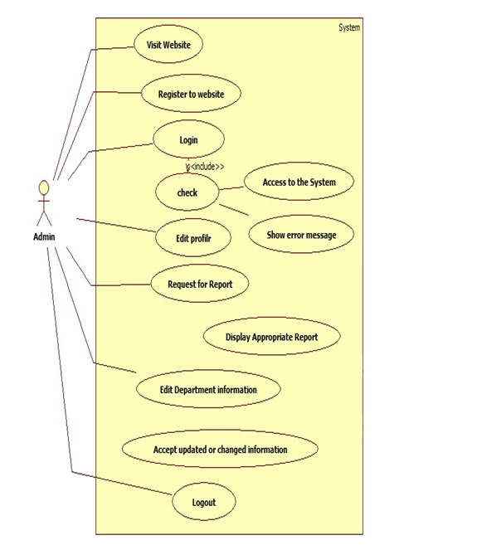

1. **Considering the second scenario as teacher (user) accessing account :**

Actors :

* + Teacher
  + System

Pre-conditions :

* System should be accessible through the computer.

Post-conditions :

* System should terminate the session after logout.

Scenarios :

* Teacher visit website.
* Teacher register to website.
* Teacher login to website.
* System must verify user ID and password.
* If correct or valid user then allow to access the system.
* If not valid user then show the error message.
* Teacher should edit their profile.
* System accept changes in profile.
* Teacher see the department information.
* System display the information.
* Teacher can logout the system.

**Use Case Diagram :**

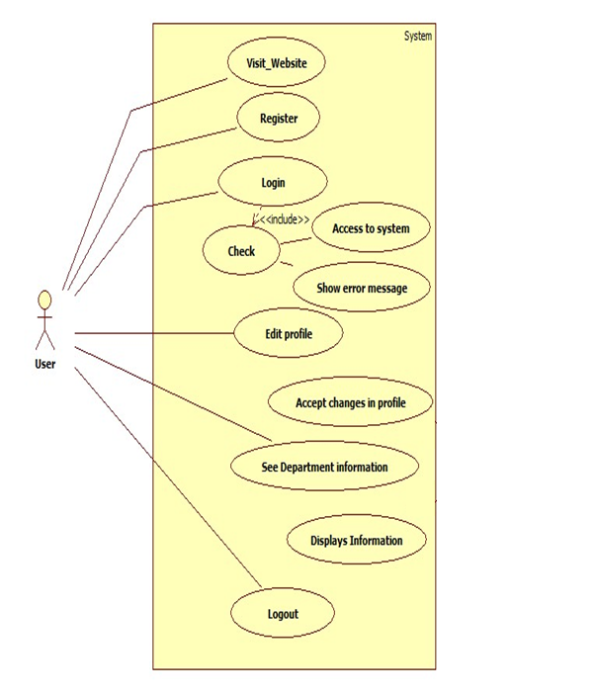

**ER DIAGRAM**

**Entity :–**

Entities are person, places, events, objects, or concepts.

**Relationship :-**

A relationship is a naturally occurring association among entities.

**ERD :-**

The traditional approach places a great deal of emphasis on data storage requirements for the new system. The model used to define the data storage requirements is called the entity-relationship diagram (ERD)

* Rectangles represent the data entities.
* Lines connecting the rectangles show relationships among the data entities.

**Following are the entities and their attributes :**

|  |  |
| --- | --- |
| **Entities** | **Attributes** |
| Teacher | Name, Id, Department, Email, Contact No., Gender, Address |
| Department | ID, Name, Year of Establishment |
| Account | User Id , password, Role |
| Registration | Name, Department, User ID, Date of Birth, Date of Appointment, |
| Login | User Id , password |
| Profile | ID, Photo |
| Qualification | Degree, University, Duration, Marks |
| Publications | Type, Date, Impact Factor, Publication Company |
| Patent | Type, Details |
| Awards | Level, Type |
| Research | Level, Type, Title, Date |
| Conference | Level, Type, Venue, Date |
| Activity | Name, Nature, Guest, Host, Notice, Report |
| Student | Class, Boys, Girls, Total Students |
| Result | Semester, Year, Class, Grade |
| Reports | Department, Academic Year |

**ERD FOR NAAC REPORTNG SYSTEM :**

**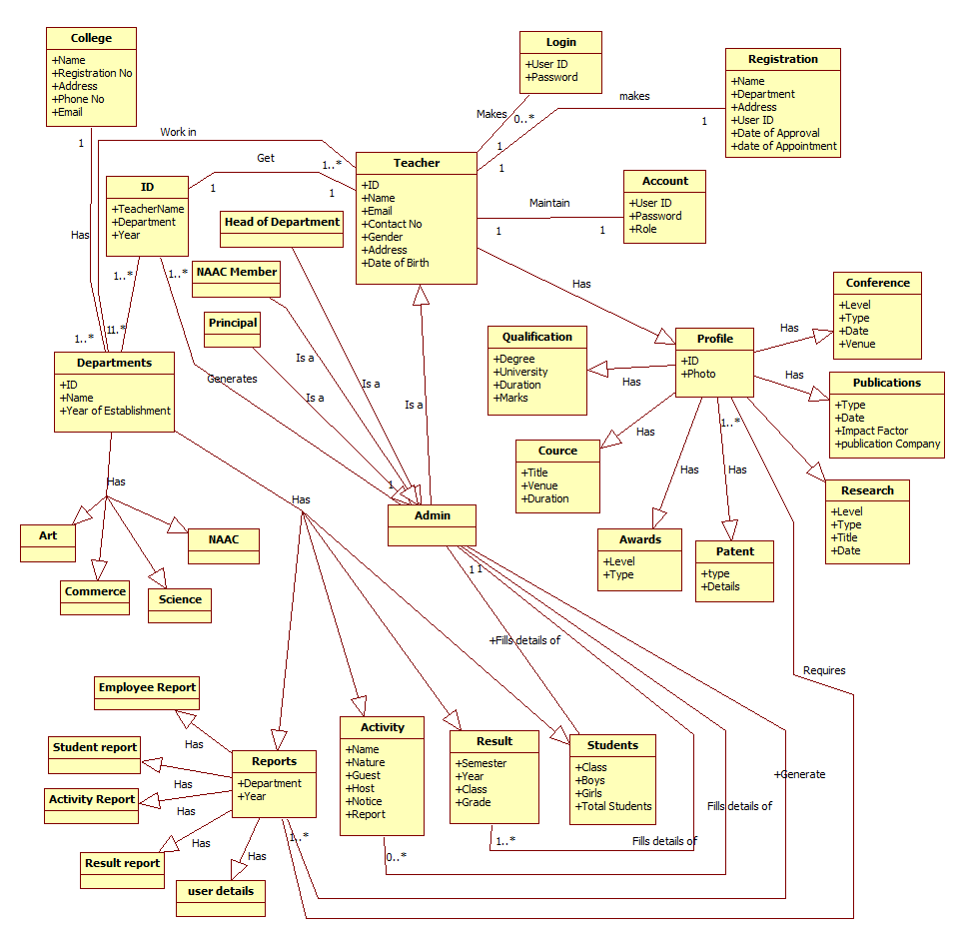**

**ACTIVITY DIAGRAM**

**Activity Diagram:-**

An activity diagram is a variant of state chart diagram organized to actions, and mainly targeted towards representing the internal behavior of a method or a use case. An activity is represented by a rounded rectangle.

**For NAAC system I considered the following Activity diagrams :**

1. Admin and System :

* Admin login to the system by providing User ID and Password.
* Admin view profile or edit profile details.
* Admin can make request for any report from options.
* System must display the specific report.
* Admin can request to produce user ID for new employee(Teacher).
* System must provide user ID .
* Admin can logout.

1. Teacher and System :

* Teacher visit website.
* New teacher can register to system by providing valid name and user ID.
* System shows message like Registration Successful.
* Teacher can make login to system by providing User ID and correct password.
* System must verify the login and allow to access their account.
* Teacher can edit their account details.
* Teacher can view the filled information.
* Teacher can logout.

**Activity Diagram for NAAC Reporting System**

1. **Admin and NAAC system :**

**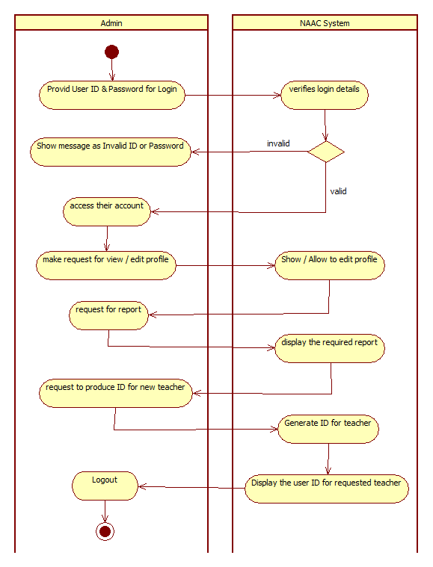**

1. **Teacher and NAAC system :**

**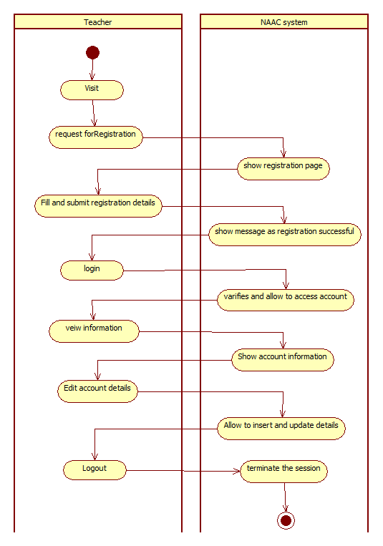**

**CLASS DIAGRAM**

**Class Diagram :-**

Class diagrams express, in a general way, the static structure of a system, in terms of classes and relationships between those classes. Just as a class describes a set of objects , an association describes a set of links, objects are class instances and links are association instances ..

The rectangle that acts as a symbol for the class may also contain a stereotype and properties. UML defines the following class stereotypes.

**Symbols used for Class Diagram :-**

|  |  |
| --- | --- |
| **Symbol** | **Meaning** |
| |  | | --- | | Class Name | | Variable member | | Function member | | Rectangular class ( Represent class ) |
| Is a | Triangle (Specialization of class ) |
| Is a | Triangle (Generalization of class ) |
|  | Connection Line |

**Following Are the Classes for NAAC System :**

|  |  |  |
| --- | --- | --- |
| **Class** | **Attributes** | **Operations** |
| Teacher | Name, Id, Department, Email, Contact No., Gender, Address | Login(), Fill\_Profile(),  Update\_Profile() |
| Department | ID, Name, Year of Establishment | Add(), Remove() |
| Account | User Id , password, Role | AddAccount() |
| Registration | Name, Department, User ID, Date of Birth, Date of Appointment, | - |
| Login | User Id , password | - |
| Profile | ID, Photo | Create(), Update(), AddDetails() |
| Qualification | Degree, University, Duration, Marks | Add() |
| Publications | Type, Date, Impact Factor, Publication Company | Add(), Remove() |
| Patent | Type, Details | Add() |
| Awards | Level, Type | Add() |
| Research | Level, Type, Title, Date | Add() |
| Conference | Level, Type, Venue, Date | Add() |
| Activity | Name, Nature, Guest, Host, Notice, Report | Add() |
| Student | Class, Boys, Girls, Total Students | Add(),Update() |
| Result | Semester, Year, Class, Grade | Add(),Update() |
| Reports | Department, Academic Year | Add() |

**Class Diagram for NAAC Reporting System**

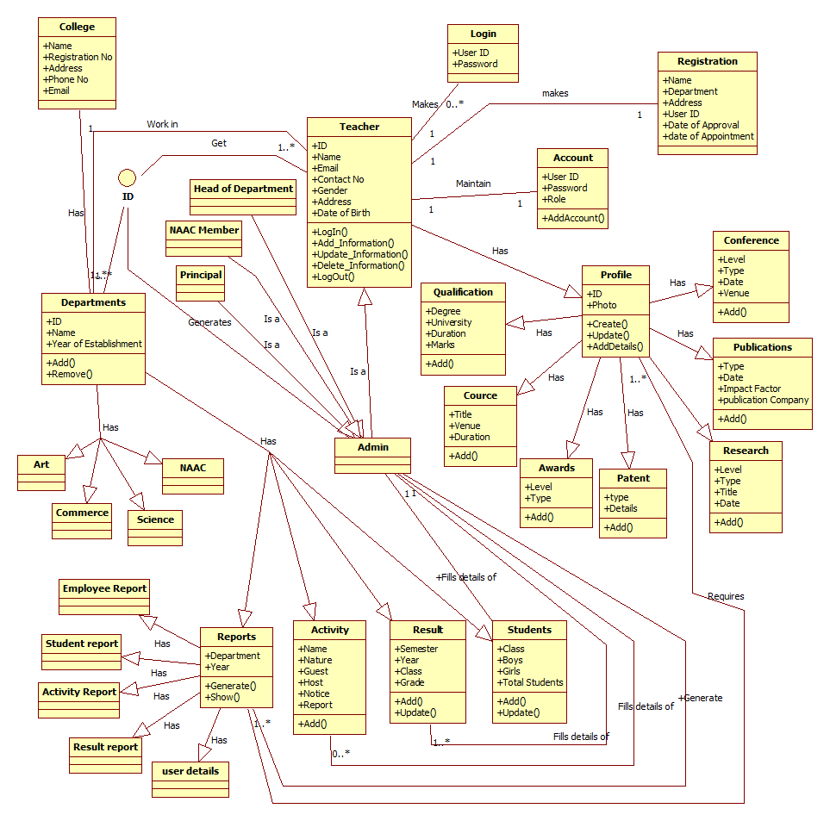

**SEQUENCE DIAGRAM**

**Sequence Diagram :-**

Sequence diagram documents the information flows within a single use case or a single scenario. Sequence diagram shows the sequence of the interaction between object that occurs during the flow of event of single scenario or use case.

**Symbols used for Sequence Diagram :-**

|  |  |
| --- | --- |
| **Symbol** | **Meaning** |
|  | Object |
|  | Life line |
|  | Active life line |
|  | Exit |

**Sequence Diagram For NAAC Reporting System**

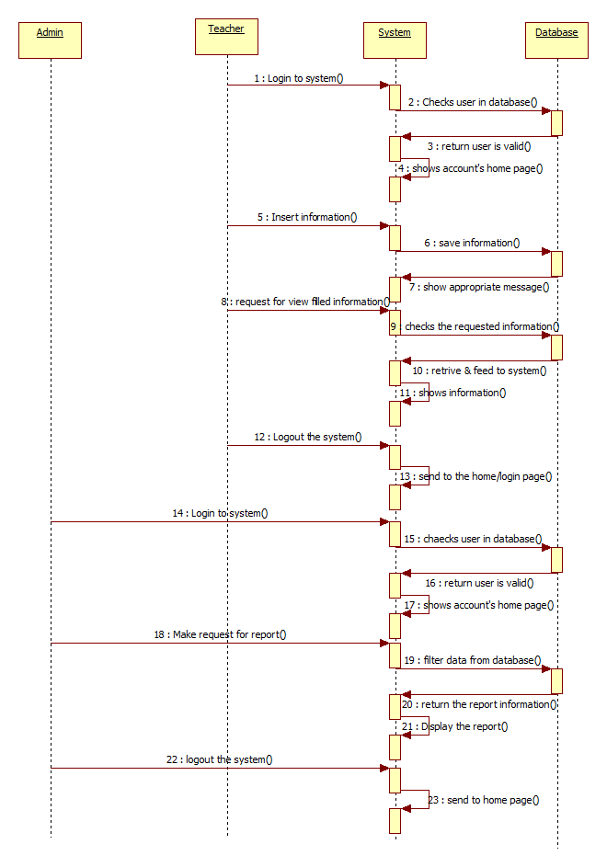

**OBJECT DIAGRAM**

**Object Diagram :-**

Object diagrams, or instance diagram, illustrate objects and links. As in the case of class diagrams, object diagrams represent the static structure. The notation used for object diagrams is derived from that of class diagrams elements that are instances are underlined.

Each object is represented by a rectangle which contains either the name of the object, the name and the class of the object or only the object’s class.

**Symbols used for Object Diagram :-**

|  |  |
| --- | --- |
| **Symbol** | **Meaning** |
|  | Rectangle ( Represent Object ) |
| Is a | Triangle (Specialization of Object ) |
| Is a | Triangle (Generalization of Object ) |
|  | Connection Line |

**Object Diagram for NAAC Reporting System**

**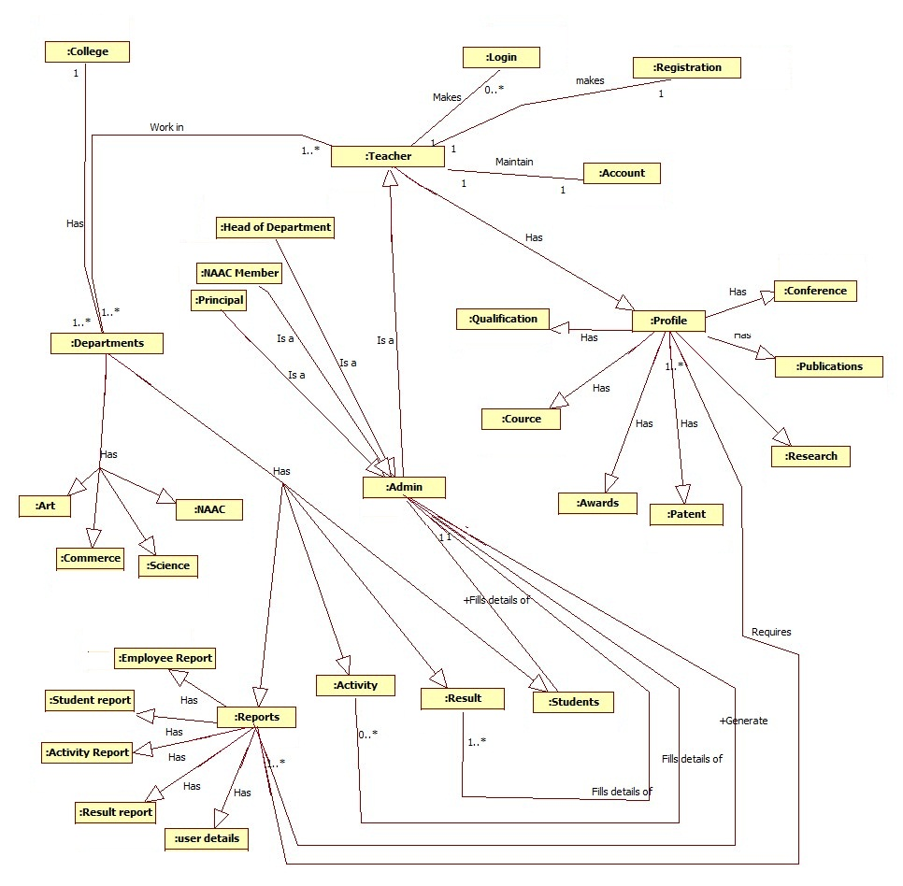**

**STATE DIAGRAM**

**State diagram :-**

State diagram shows the different states of the system.

**Symbols used for State Diagram :-**

|  |  |
| --- | --- |
| **Symbols** | **Meaning** |
| C:\Documents and Settings\india\My Documents\sample.files\page_1.png | State |
|  | Connection Line |
| C:\Documents and Settings\india\My Documents\sample.files\page_1.png | Start |
| C:\Documents and Settings\india\My Documents\sample.files\page_1.png | End |

**State Diagram For Naac reporting System**

**Login Process**

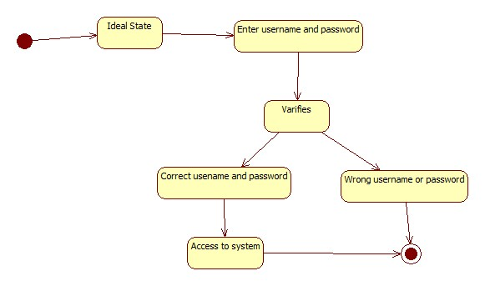

**Report Generation Process**

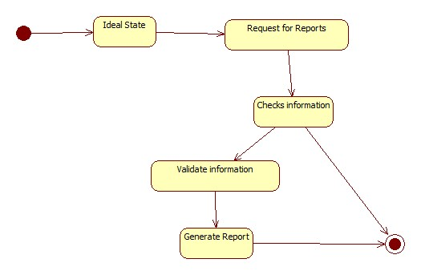

**CHAPTER – IV**

**SYSTEM CODING**

**DATABASE DESIGN**

**Teacher info**

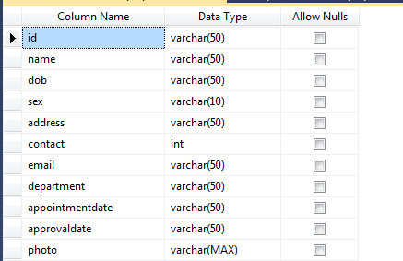

**Department info**

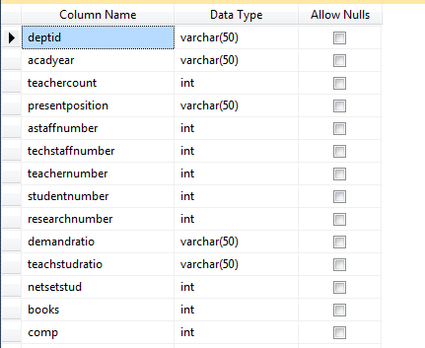

**Department Event**

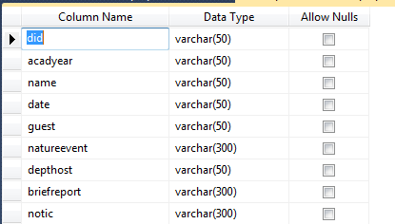

**Qualification**

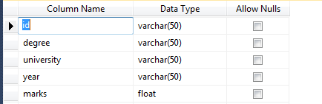

**Research Article**

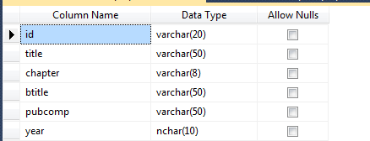

**Research Award**

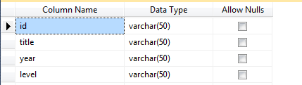

**Research Guide**

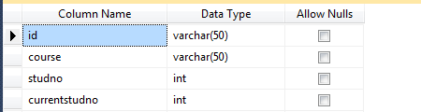

**Conference Proceeding**

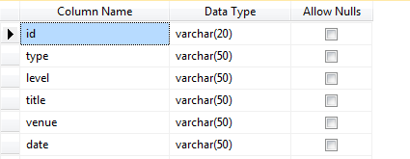

**MajorMinor Project**

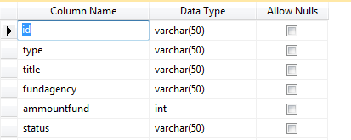

**Orientation Course**

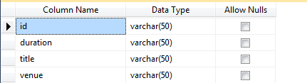

**Publication Research**

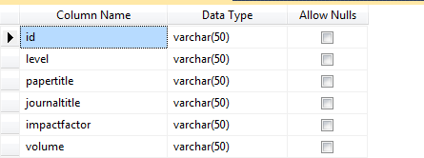

**Activity**

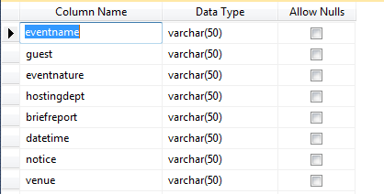

**Book**

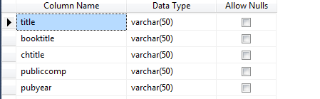

**Consultancy**

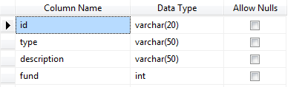

**Feedback**

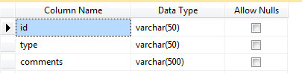

**COMPONENT DIAGRAM**

1. Presence of association and role information shows that the diagram represents classes of nodes. The diagram shows a system composed of a server with surrounding PC’s that drive the opening and closing gates. The number of PC’s has not been established conversely it appears that every PC may control at most 10 gates. 3 x terminal play the role of console to access the system. A printer is connected to the server.
2. Component diagram describes software component and their relationship within the implementation environment.
3. By default each class in the logical model as a specification and a body. The specification contains the class interface shown with UML lollipop notation while the body contains the implementation of that same class represent by a component symbol itself.

**Symbols used for Component Diagram :-**

|  |  |
| --- | --- |
| **Symbols** | **Meaning** |
| Customer | Component |
|  | Lollipop ( Use to specification ) |

**Component Diagram For NAAC Reporting System**

**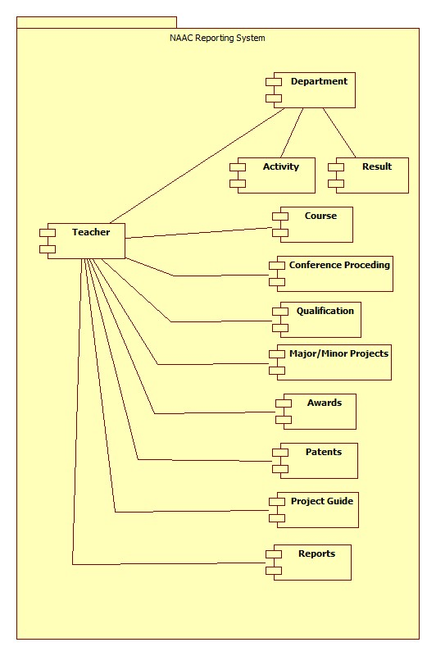**

**SITE MAP**

**General Scenario**

NAAC

Reporting

System

**HOME**

**LOG IN**

**SIGN UP**

**CONTACT US**

**Scenario (Admin LOG IN)**

NAAC

Reporting

System

**HOME**

**TEACHERS DETAILS**

**DEPARTMENT INFORMATION**

**DEPARTMENTS**

**EDIT INFORMATION**

**REPORTS**

**View Course Details**

**View Qualification Details**

**MY PROFILE**

**View Publications**

**View Conference Details**

**View Research Details**

**View Consultancy**

**View Innovations and Patents Details**

**Edit Profile**

**NEW ACCOUNT**

**CONTACT US**

**LOG OUT**

**Scenario (Teacher LOG IN)**

NAAC

Reporting

System

**HOME**

**TEACHERS DETAILS**

**DEPARTMENT INFORMATION**

**DEPARTMENTS**

**View Qualification Details**

**MY PROFILE**

**View Course Details**

**View Publications**

**View Research Details**

**View Conference Details**

**View Consultancy**

**Edit Profile**

**View Innovations and Patents Details**

**CONTACT US**

**FEEDBACK**

**LOG OUT**

**FORM & MODULE DESIGNS**

**Home screen**

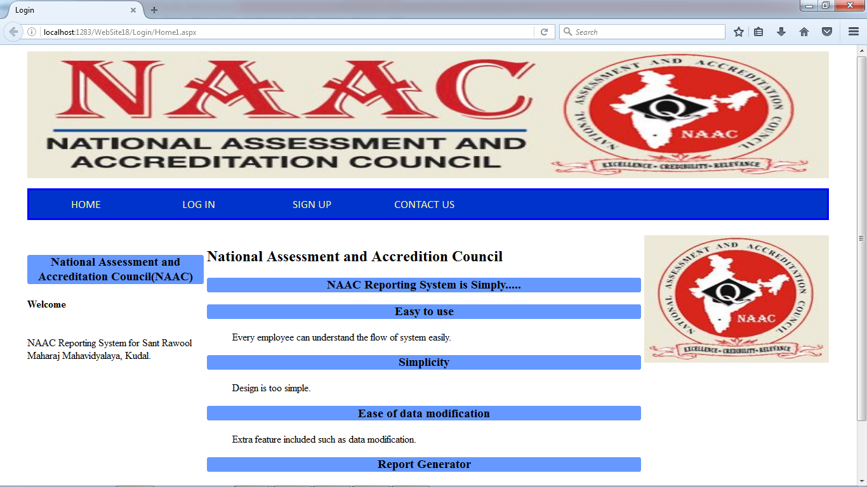

**Login Form**

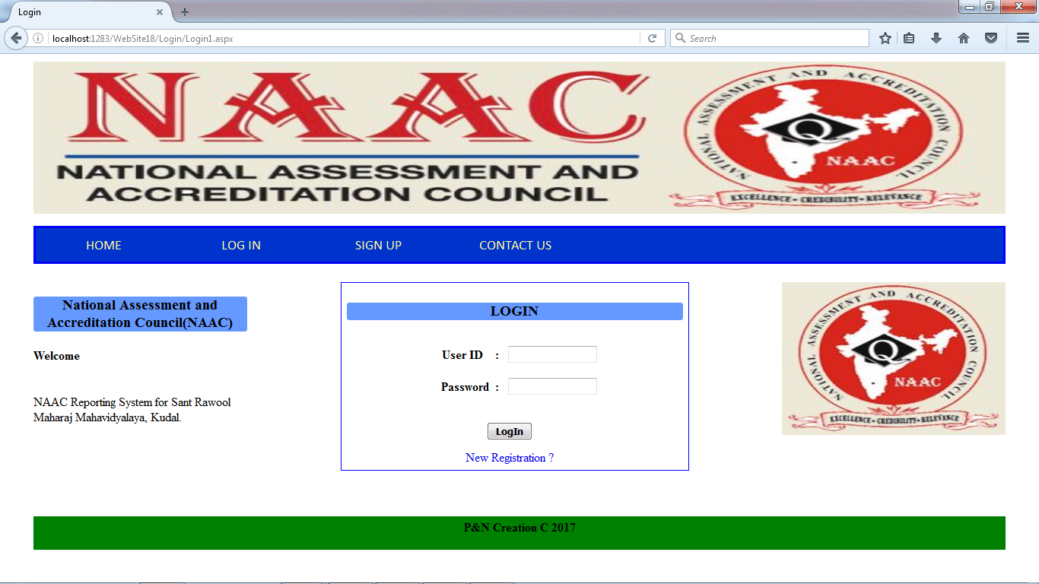

**Account form (Admin)**

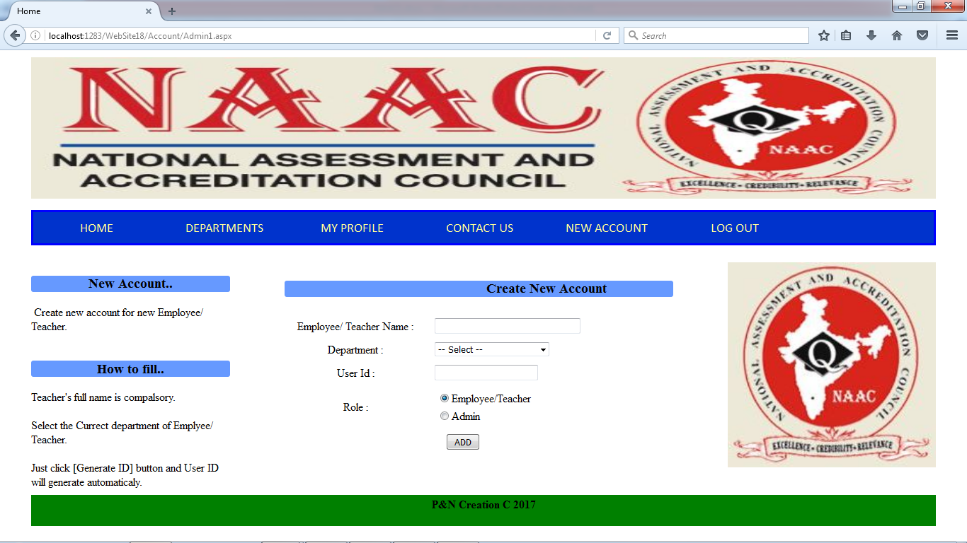

**Registraion form**

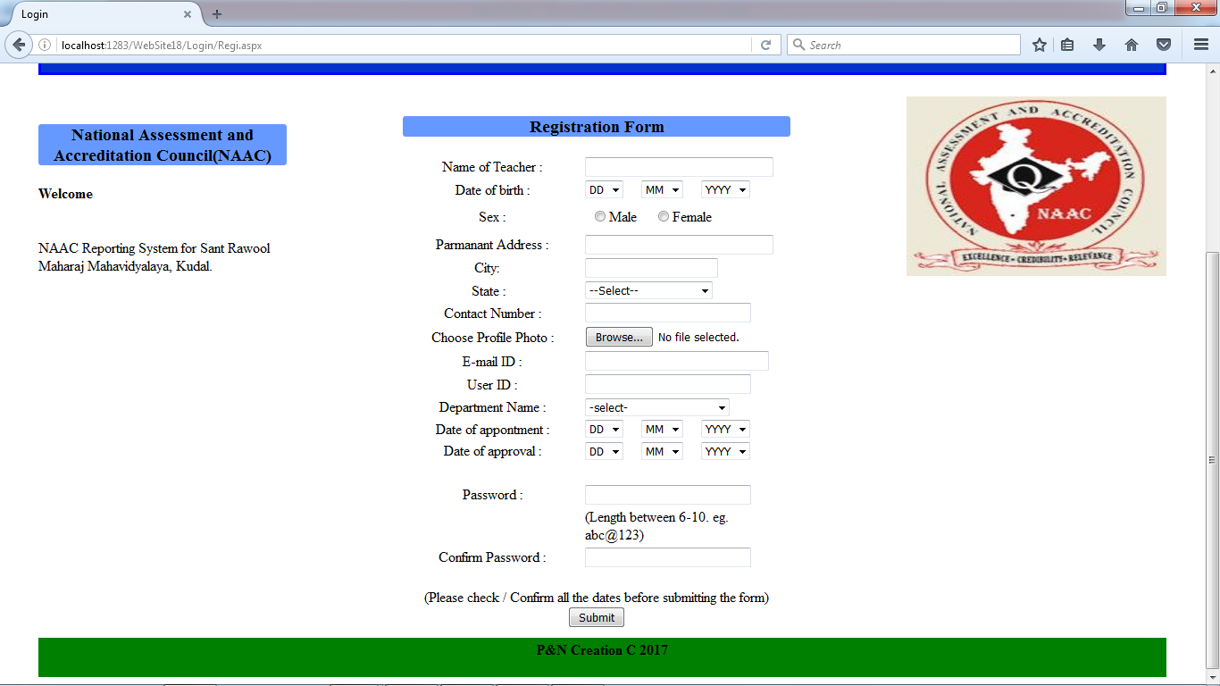

**Department Details form**

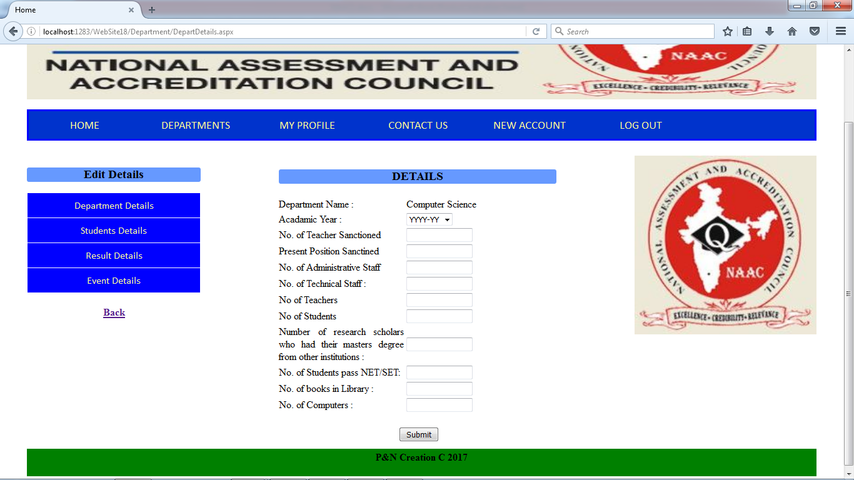

**Student Details Form**

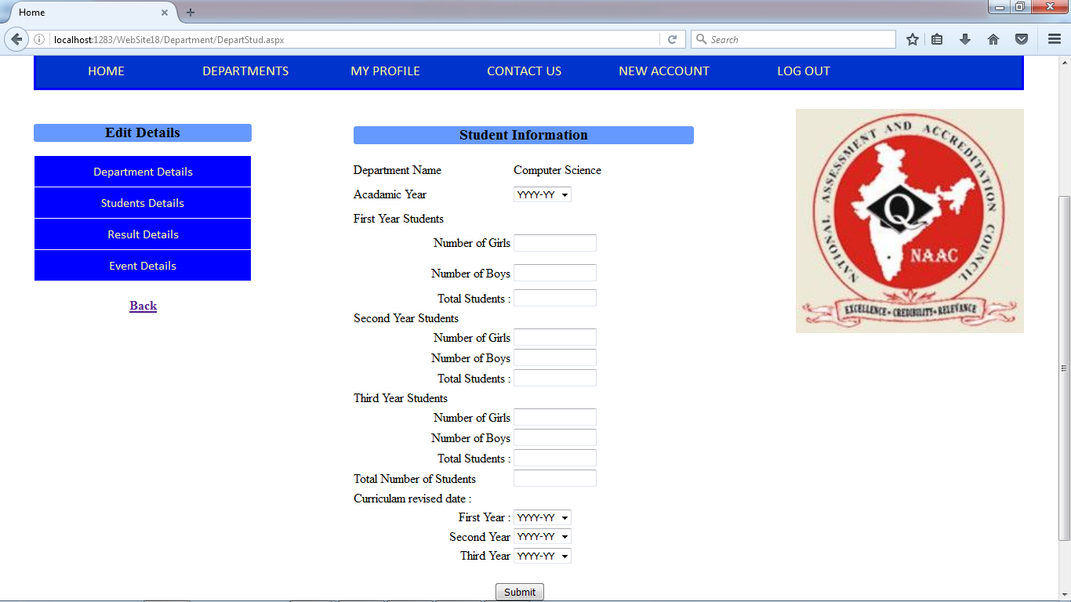

**Result Details Form**

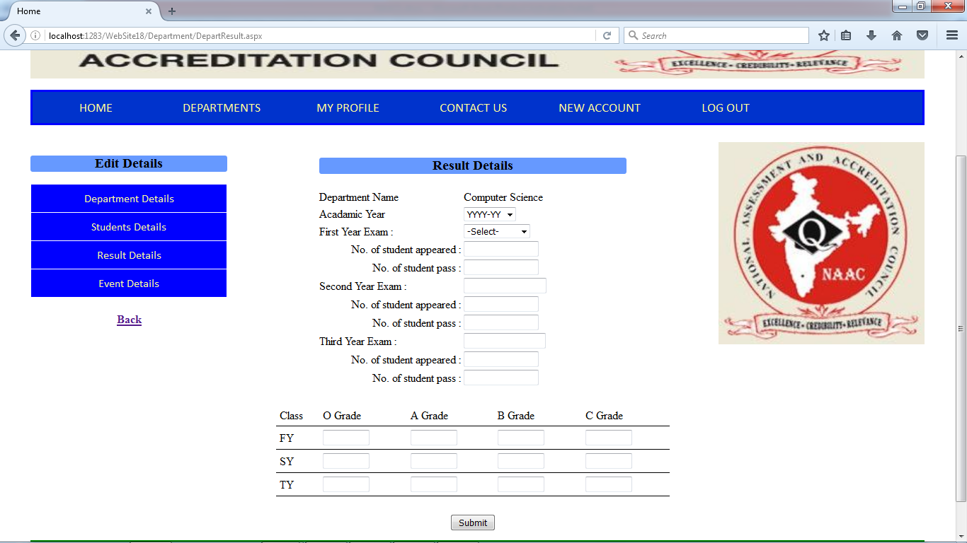

**Event Details form**

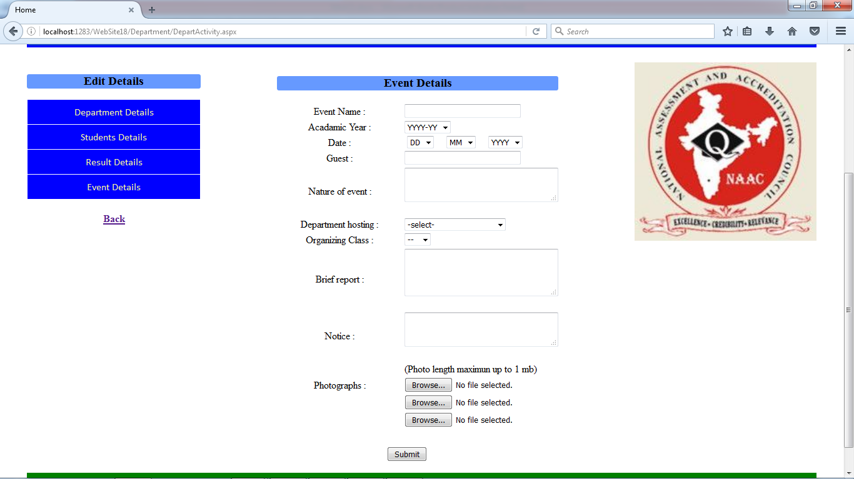

**Qualification Details form**

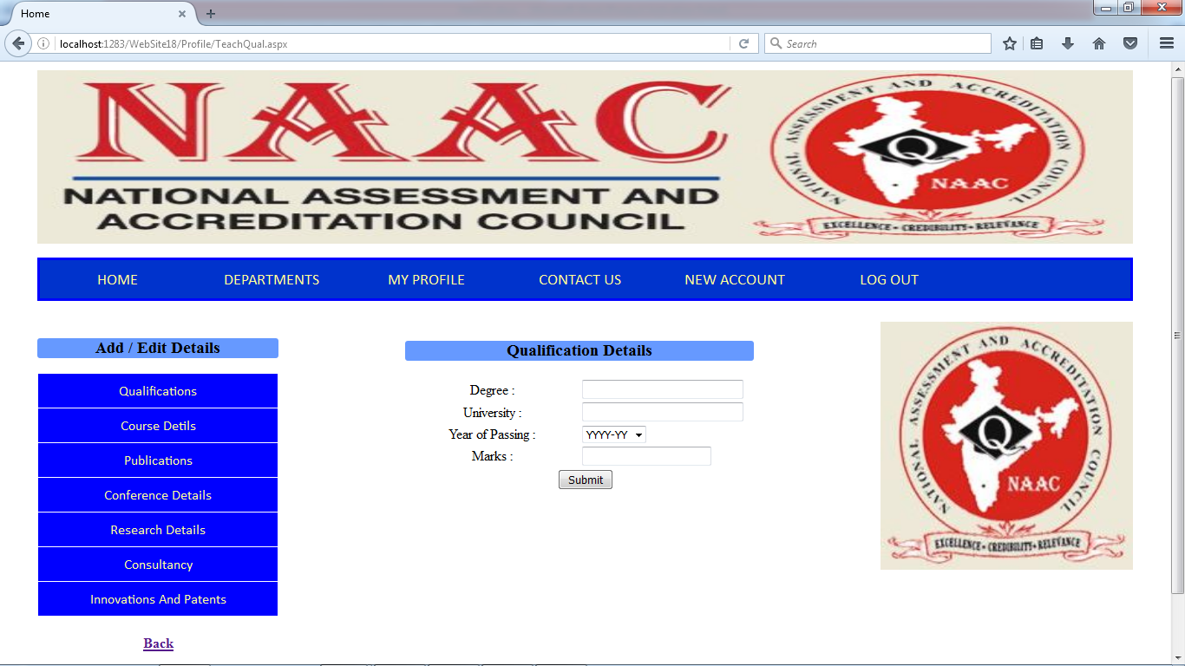

**Course Details form**

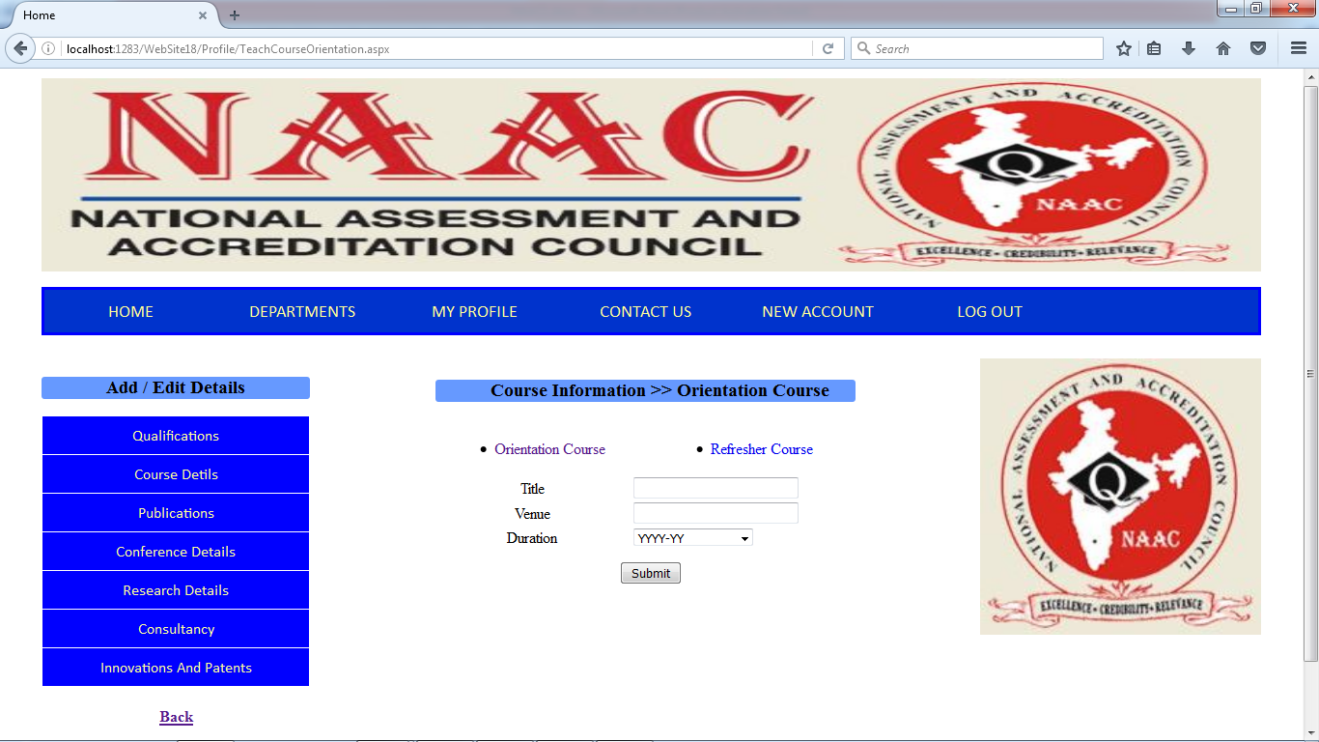

**Publication Details form**

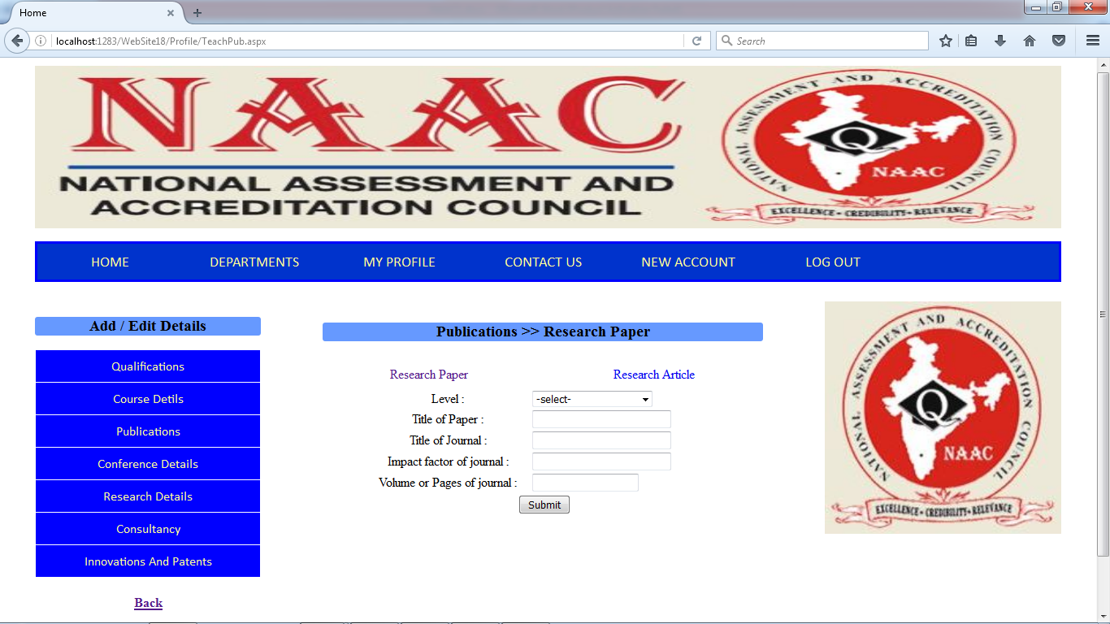

**Conference Details form**

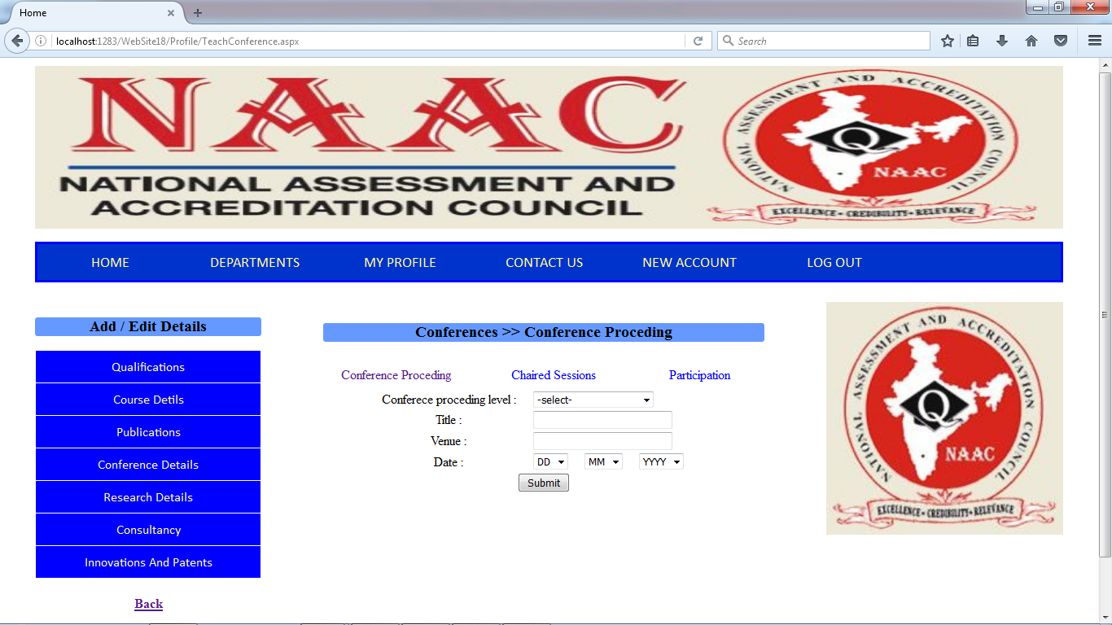

**Research Details form**

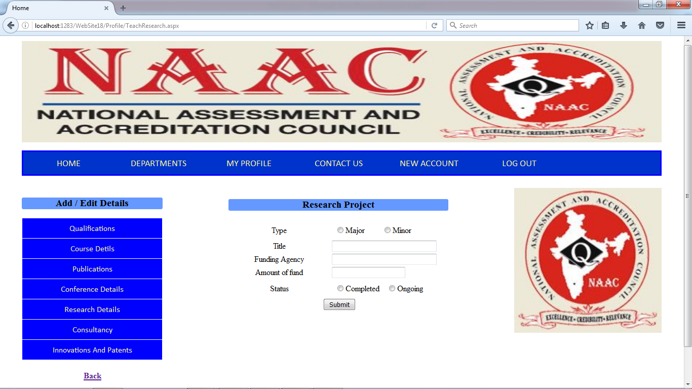

**Consultancy Details form**

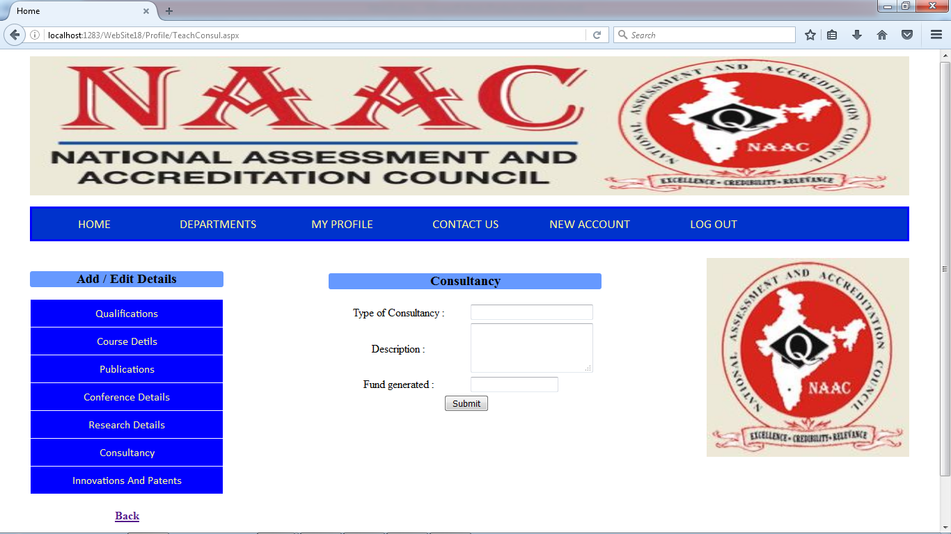

**Innovations and Patents Details form**

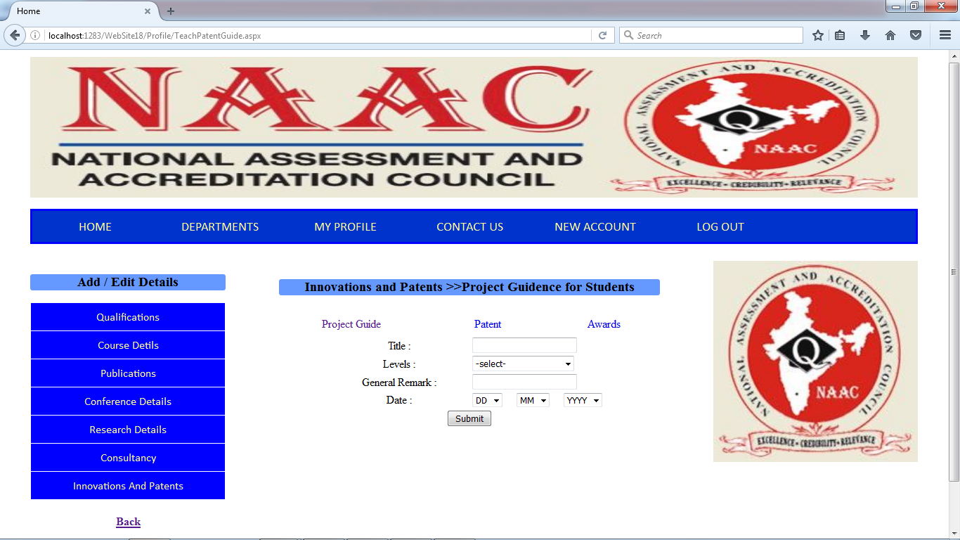

**Employee Report**

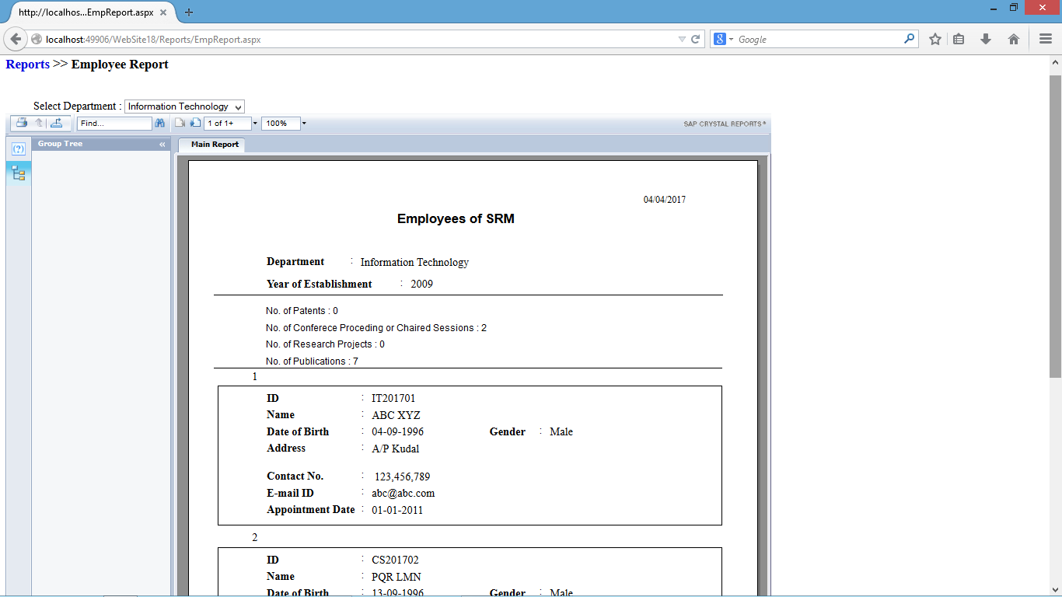

**Student Report**

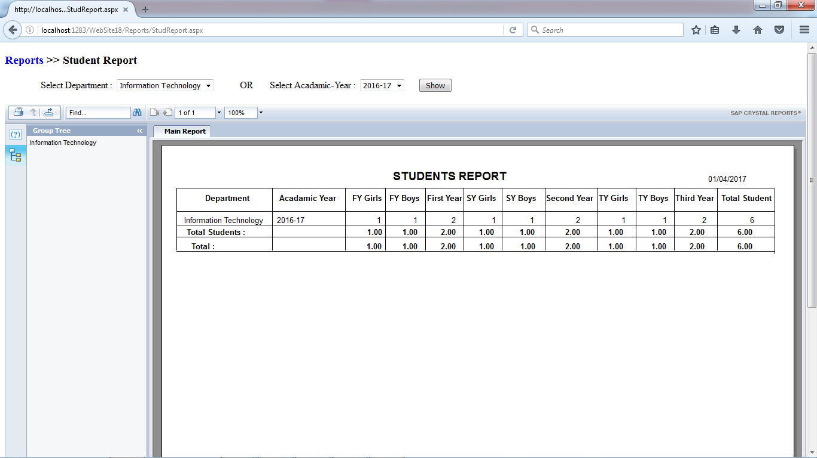

**Result Report**

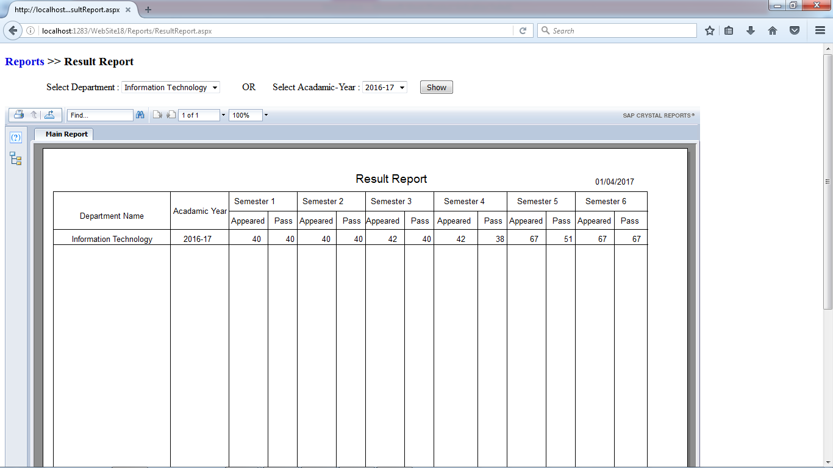

**Event report**

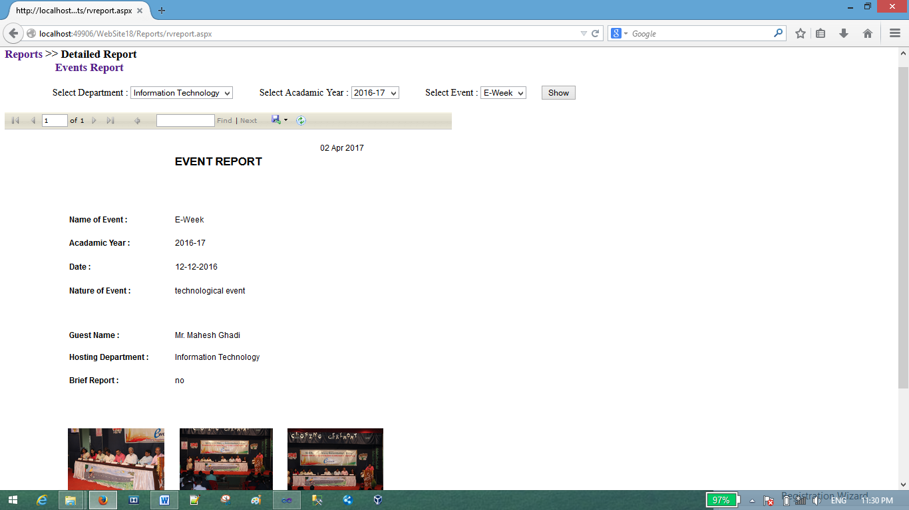

**System report**

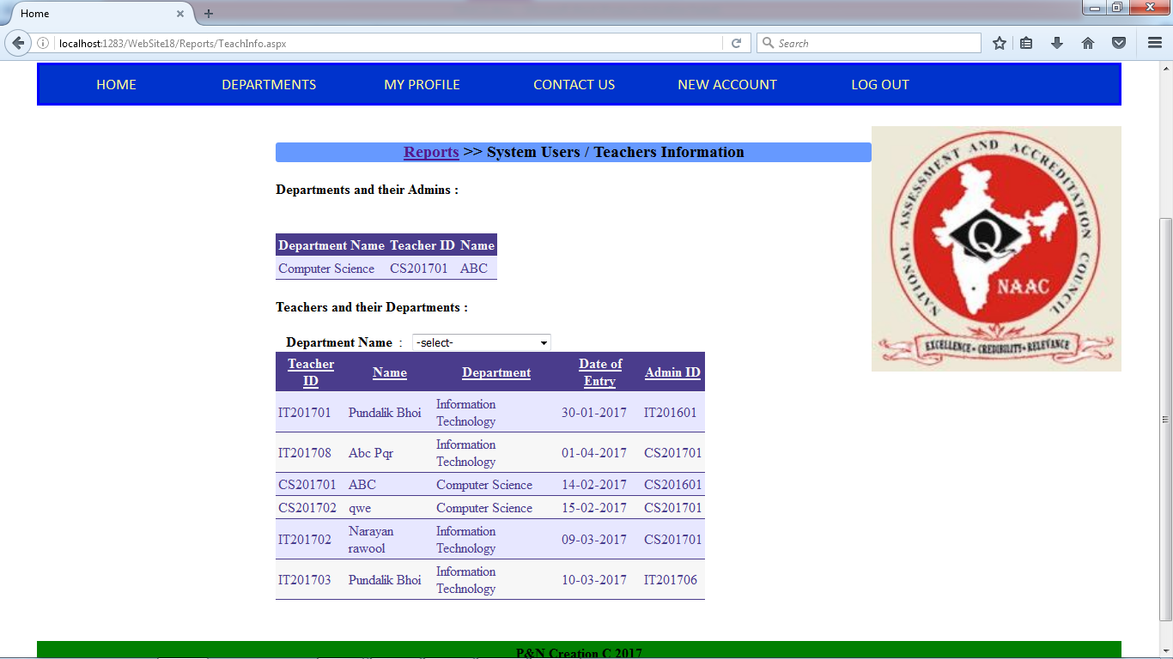

**PROGRAM LISTING**

* Home
* Departments
  + Department Information (Save , Display)
  + Teacher Details (Display)
  + Edit Information (Save, Update)
    - Department Details
    - Student Details
    - Result Details
    - Event Details
  + Reports (Filter, Retrieve)
    - Employee Report
    - Student Report
    - Result Report
    - Event Report
    - System Report
  + My Profile (Display)
    - View Qualification Details
    - View Course Details
    - View Publications
    - View Conference Details
    - View Research Details
    - View Consultancy
    - View Innovations and Patents Details
    - Edit Profile (Save, Update)
      * Qualification Details
      * Course Details
      * Publications
      * Conference Details
      * Research Details
      * Consultancy
      * Innovations and Patents Details
  + Contact Us
  + New Account(Insert)
  + Feedback(Insert)
  + Log out

**FORM CODING**

**Master Form**

<%@ Master Language="C#" AutoEventWireup="true" CodeFile="Home1.master.cs" Inherits="Home1" %>

<!DOCTYPE html PUBLIC "-//W3C//DTD XHTML 1.0 Transitional//EN" "http://www.w3.org/TR/xhtml1/DTD/xhtml1-transitional.dtd">

<html xmlns="http://www.w3.org/1999/xhtml">

<head runat="server">

<title>Login</title>

<asp:ContentPlaceHolder id="head" runat="server">

</asp:ContentPlaceHolder>

<link href="../Styles/StyleSheet.css" rel="stylesheet" type="text/css" />

<link href="../Styles/StyleSheetH.css" rel="stylesheet" type="text/css" />

<link href="../Styles/StyleSheetSM.css" rel="stylesheet" type="text/css" />

<style type="text/css">

.style1

{

width: 100%;

height: 201px;

}

</style>

</head>

<body>

<form id="form1" runat="server">

<div id="bodyBlock">

<div id="headerBlock">

<img src="../Images/naac.JPG" style="width:100%; min-height:195px; max-height:200px;"/>

</div>

<div id="menu" >

<ul>

<li> <a href="../Login/Home1.aspx">HOME</a></li>

<li> <a href="../Login/Login1.aspx">LOG IN</a> </li>

<li> <a href="../Login/Regi.aspx">SIGN UP</a></li>

<li> <a href="../Login/Contact.aspx">CONTACT US</a></li>

</ul>

</div>

<div id="content">

<div id="bodyMenu">

<marquee direction="up" height="300px">

<h3>National Assessment and Accreditation Council(NAAC)</h3>

<h4>Welcome</h4> <br />

NAAC Reporting System for Sant Rawool Maharaj Mahavidyalaya, Kudal.

</marquee>

<asp:ContentPlaceHolder ID="ContentPlaceHolder2" runat="server">

</asp:ContentPlaceHolder>

</div>

<div id="bodyContent">

<asp:ContentPlaceHolder ID="ContentPlaceHolder1" runat="server">

</asp:ContentPlaceHolder> </div>

<div id="bodyRight">

<img alt="NAAC1" class="style1" src="../Images/naac1.JPG"/></div>

</div> <div id="footerContent">

<b> P&N Creation C 2017</b>

<p> </p>

</form>

</body>

</html>

**Department Details Form**

using System;

using System.Collections.Generic;

using System.Linq;

using System.Web;

using System.Web.UI;

using System.Web.UI.WebControls;

using System.Configuration;

using System.Data;

using System.Data.SqlClient;

public partial class Department\_DepartDetails : System.Web.UI.Page

{

SqlConnection con;

SqlCommand cmd;

SqlDataReader dr;

SqlDataAdapter da;

DataTable dt;

string did;

int d;

protected void Page\_Load(object sender, EventArgs e)

{

con = new SqlConnection("Data Source=localhost\\sqlexpress;Initial Catalog=NAAC;Integrated Security=True;Pooling=False");

con.Open();

cmd = new SqlCommand("select department from TeachPersonal where id='" + Session["id"].ToString() + "'", con);

dr = cmd.ExecuteReader();

while (dr.Read())

{

LblDName.Text = dr[0].ToString();

}

dr.Close();

con.Close();

}

protected void Button1\_Click(object sender, EventArgs e)

{

if (TextAdn.Text == "" || Textbook.Text == "" || Textcomp.Text == "" || TextNSStud.Text == "" || TextPosS.Text == "" || TextResSc.Text == "" || TextStud.Text == "" || TextTeach.Text == "" || TextTeachS.Text == "" || TextTechStaff.Text == "")

{

}

else

{

con.Open();

string dname = LblDName.Text;

string acadyear = DropAcadYear.Text;

int teachs = Convert.ToInt16(TextTeachS.Text);

int post = Convert.ToInt16(TextPosS.Text);

int adnstaff = Convert.ToInt16(TextAdn.Text);

int techstaff = Convert.ToInt16(TextTechStaff.Text);

int teach = Convert.ToInt16(TextTeach.Text);

int stud = Convert.ToInt16(TextStud.Text);

int reserchsc = Convert.ToInt16(TextResSc.Text);

int netset = Convert.ToInt16(TextNSStud.Text);

int book = Convert.ToInt16(Textbook.Text);

int comp = Convert.ToInt16(Textcomp.Text);

cmd = new SqlCommand("select did from Departments where depart='" + dname + "'", con);

dr = cmd.ExecuteReader();

while (dr.Read())

{

did = dr[0].ToString();

}

dr.Close();

cmd = new SqlCommand("select \* from DeptTable1 where deptid='" + did + "' and acadyear='" + acadyear + "'", con);

dr = cmd.ExecuteReader();

if (dr.HasRows)

{

d = 1;

}

dr.Close();

if (d == 1)

{

cmd = new SqlCommand("update DeptTable1 set teachercount=" + teachs + ", presentposition=" + post + ", astaffnumber=" + adnstaff + ", techstaffnumber=" + techstaff + ", teachernumber=" + teach + ", studentnumber=" + stud + ", researchnumber=" + reserchsc + ", netsetstud=" + netset + ", books=" + book + ", comp=" + comp + " where deptid='" + did + "' and acadyear='" + acadyear + "'", con);

cmd.ExecuteNonQuery();

}

else

{

cmd = new SqlCommand("insert into DeptTable1 (deptid,acadyear,teachercount,presentposition,astaffnumber,techstaffnumber,teachernumber,studentnumber,researchnumber,demandratio,teachstudratio,netsetstud,books,comp) values('" + did + "','" + acadyear + "'," + teachs + "," + post + "," + adnstaff + "," + techstaff + "," + teach + "," + stud + "," + reserchsc + ",1,1," + netset + "," + book + "," + comp + ")", con);

cmd.ExecuteNonQuery();

}

con.Close();

Response.Redirect("../Department/DepartDetailsS.aspx");

}

}

protected void DropAcadYear\_SelectedIndexChanged(object sender, EventArgs e)

{

con.Open();

string dname = LblDName.Text;

string acadyear = DropAcadYear.Text;

cmd = new SqlCommand("select did from Departments where depart='" + dname + "'", con);

dr = cmd.ExecuteReader();

while (dr.Read())

{

did = dr[0].ToString();

}

dr.Close();

cmd = new SqlCommand("select \* from DeptTable1 where deptid='" + did + "' and acadyear='" + acadyear + "'", con);

dr = cmd.ExecuteReader();

if (dr.HasRows)

{

while (dr.Read())

{

TextTeachS.Text = dr["teachercount"].ToString();

TextPosS.Text = dr["presentposition"].ToString();

TextAdn.Text = dr["astaffnumber"].ToString();

TextTechStaff.Text = dr["techstaffnumber"].ToString();

TextTeach.Text = dr["teachernumber"].ToString();

TextStud.Text = dr["studentnumber"].ToString();

TextResSc.Text = dr["researchnumber"].ToString();

TextNSStud.Text = dr["netsetstud"].ToString();

Textbook.Text = dr["books"].ToString();

Textcomp.Text = dr["comp"].ToString();

Button1.Text = "Update";

}

}

else

{

TextTeachS.Text = null;

TextPosS.Text = null;

TextAdn.Text = null;

TextTechStaff.Text = null;

TextTeach.Text = null;

TextStud.Text = null;

TextResSc.Text = null;

TextNSStud.Text = null;

Textbook.Text = null;

Textcomp.Text = null;

Button1.Text = "Submit";

}

con.Close();

}

}

**Code For Submit Button:**

public partial class Profile\_TeachPatentAward : System.Web.UI.Page

{

SqlConnection con;

SqlCommand cmd;

SqlDataReader dr;

SqlDataAdapter da;

DataTable dt;

string depart;

protected void Page\_Load(object sender, EventArgs e)

{

con = new SqlConnection("Data Source=localhost\\sqlexpress;Initial Catalog=NAAC;Integrated Security=True;Pooling=False");

con.Open();

}

protected void Button1\_Click(object sender, EventArgs e)

{

cmd = new SqlCommand("select department from TeachPersonal where id='" + Session["id"].ToString() + "'", con);

dr = cmd.ExecuteReader();

while (dr.Read())

{

depart = dr[0].ToString();

}

dr.Close();

cmd = new SqlCommand("select did from Departments where depart='" + depart + "'", con);

dr = cmd.ExecuteReader();

depart = "";

while (dr.Read())

{

depart = dr[0].ToString();

}

dr.Close();

string id = Session["id"].ToString();

string type = RadioButtonList1.SelectedItem.Text;

string level = DropDownList3.SelectedItem.Text;

string title = RadioButtonList3.SelectedItem.Text;

if (RadioButtonList1.SelectedItem.Text.Equals("Research Award"))

{

cmd = new SqlCommand("insert into ResearchAwards values('" + id + "','" + title + "','"+Dropyear.SelectedItem.Text+"','" + level + "')", con);

cmd.ExecuteNonQuery();

}

if (RadioButtonList1.SelectedItem.Text.Equals("Other Award"))

{

cmd = new SqlCommand("insert into OtherAwards values('" + id + "','" + title + "','" + Dropyear.SelectedItem.Text + "','" + level + "')", con);

cmd.ExecuteNonQuery();

}

cmd = new SqlCommand("insert into DeptTable6 values('" + depart + "','" + Session["id"].ToString() + "',0,0,0,0,0,0,1,0)", con);

cmd.ExecuteNonQuery();

Response.Redirect("../Profile/TeachPatentAwardConfirm.aspx");

}

}

**Code For Modify/update Button:**

protected void Button1\_Click(object sender, EventArgs e)

{

string dname = LblDName.Text;

string acadyear = DropAcadYear.Text;

string sem = DropFySem.SelectedValue;

int sem1a=Convert.ToInt16(TextFya.Text);

int sem1p=Convert.ToInt16(TextFyp.Text);

int sem3a=Convert.ToInt16(TextSya.Text);

int sem3p=Convert.ToInt16(TextSyp.Text);

int sem5a=Convert.ToInt16(TextTya.Text);

int sem5p=Convert.ToInt16(TextTyp.Text);

int sem2a=Convert.ToInt16(TextFya.Text);

int sem2p=Convert.ToInt16(TextFyp.Text);

int sem4a=Convert.ToInt16(TextSya.Text);

int sem4p=Convert.ToInt16(TextSyp.Text);

int sem6a=Convert.ToInt16(TextTya.Text);

int sem6p=Convert.ToInt16(TextTyp.Text);

int fyo = Convert.ToInt16(TextFyO.Text);

int fya = Convert.ToInt16(TextFyAa.Text);

int fyb = Convert.ToInt16(TextFyB.Text);

int fyc = Convert.ToInt16(TextFyC.Text);

int syo = Convert.ToInt16(TextSyO.Text);

int sya = Convert.ToInt16(TextSyAa.Text);

int syb = Convert.ToInt16(TextSyB.Text);

int syc = Convert.ToInt16(TextSyC.Text);

int tyo = Convert.ToInt16(TextTyO.Text);

int tya = Convert.ToInt16(TextTyAa.Text);

int tyb = Convert.ToInt16(TextTyB.Text);

int tyc = Convert.ToInt16(TextTyC.Text);

cmd = new SqlCommand("select did from Departments where depart='" + dname + "'", con);

dr = cmd.ExecuteReader();

while (dr.Read())

{

did = dr["did"].ToString();

}

dr.Close();

cmd = new SqlCommand("select \* from DepartResult1 where did='" + did + "' and acadyear='" + acadyear + "'", con);

dr = cmd.ExecuteReader();

if (dr.HasRows)

{

b = 1;

}

dr.Close();

if (sem == "Semester-1")

{

if (b == 1)

{

cmd = new SqlCommand("update DepartResult1 set sem1a="+sem1a+", sem1p="+sem1p+", sem3a="+sem3a+", sem3p="+sem3p+", sem5a="+sem5a+", sem5p="+sem5p+" where did='" + did + "' and acadyear='" + acadyear + "'", con);

cmd.ExecuteNonQuery();

}

else{ cmd = new SqlCommand("insert into DepartResult1 values('" + did + "','" + acadyear + "',"+sem1a+","+sem1p+",0,0,"+sem3a+","+sem3p+",0,0,"+sem5a+","+sem5p+",0,0)", con);

cmd.ExecuteNonQuery();

}

}

if (sem == "Semester-2")

{ if (b == 1)

{

cmd = new SqlCommand("update DepartResult1 set sem2a=" + sem2a + ", sem2p=" + sem2p + ", sem4a=" + sem4a + ", sem4p=" + sem4p + ", sem6a=" + sem6a + ", sem6p=" + sem6p + " where did='" + did + "' and acadyear='" + acadyear + "'", con);

cmd.ExecuteNonQuery();

} else

{

cmd = new SqlCommand("insert into DepartResult1 values('" + did + "','" + acadyear + "',0,0," + sem2a + "," + sem2p + ",0,0," + sem4a + "," + sem4p + ",0,0," + sem6a + "," + sem6p + ")", con);

cmd.ExecuteNonQuery();

}

}

cmd = new SqlCommand("select \* from DepartResult2 where did='" + did + "' and acadyear='" + acadyear + "' and sem='"+sem+"'", con);

dr = cmd.ExecuteReader();

if (dr.HasRows)

{ d = 1; }

dr.Close();

if (sem == "Semester-1")

{ if (d == 1)

{

cmd = new SqlCommand("update DepartResult2 set fyo=" + fyo + ",fya=" + fya + ",fyb=" + fyb + ",fyc=" + fyc + ",syo=" + syo + ",sya=" + sya + ",syb=" + syb + ",syc=" + syc + ",tyo=" + tyo + ",tya=" + tya + ",tyb=" + tyb + ",tyc=" + tyc + " where did='" + did + "' and acadyear='" + acadyear + "' and sem='" + sem + "'", con);

cmd.ExecuteNonQuery();

d = 0;

}

else

{ cmd = new SqlCommand("insert into DepartResult2 values('" + did + "','" + acadyear + "','"+sem+"',"+fyo+","+fya+","+fyb+","+fyc+","+syo+","+sya+","+syb+","+syc+","+tyo+","+tya+","+tyb+","+tyc+")", con);

cmd.ExecuteNonQuery();

d = 0;

} }

if (sem == "Semester-2")

{ if (d == 1)

{

cmd = new SqlCommand("update DepartResult2 set fyo=" + fyo + ",fya=" + fya + ",fyb=" + fyb + ",fyc=" + fyc + ",syo=" + syo + ",sya=" + sya + ",syb=" + syb + ",syc=" + syc + ",tyo=" + tyo + ",tya=" + tya + ",tyb=" + tyb + ",tyc=" + tyc + " where did='" + did + "' and acadyear='" + acadyear + "' and sem='" + sem + "'", con);

cmd.ExecuteNonQuery();

d = 0;

}

else

{

cmd = new SqlCommand("insert into DepartResult2 values('" + did + "','" + acadyear + "','" + sem + "'," + fyo + "," + fya + "," + fyb + "," + fyc + "," + syo + "," + sya + "," + syb + "," + syc + "," + tyo + "," + tya + "," + tyb + "," + tyc + ")", con);

cmd.ExecuteNonQuery();

d = 0;

} }

Response.Redirect("../Department/DepartResultS.aspx");

}

**Code For Delete Button:**

<asp:GridView ID="GridView1" runat="server" AutoGenerateColumns="False"

CellPadding="4" DataSourceID="SqlDataSource1" DataKeyNames="Degree,University,Year,Marks" ForeColor="#333333"

GridLines="None" Width=400px>

<AlternatingRowStyle BackColor="White" />

<Columns>

<asp:CommandField ShowDeleteButton="True" />

<asp:BoundField DataField="degree" HeaderText="Degree"

SortExpression="degree" />

<asp:BoundField DataField="university" HeaderText="University"

SortExpression="university" />

<asp:BoundField DataField="year" HeaderText="Year Of Passing"

SortExpression="year" />

<asp:BoundField DataField="marks" HeaderText="Marks" SortExpression="marks" />

</Columns>

<EditRowStyle BackColor="#2461BF" />

<FooterStyle BackColor="#507CD1" Font-Bold="True" ForeColor="White" />

<HeaderStyle BackColor="#507CD1" Font-Bold="True" ForeColor="White" />

<PagerStyle BackColor="#2461BF" ForeColor="White" HorizontalAlign="Center" />

<RowStyle BackColor="#EFF3FB" />

<SelectedRowStyle BackColor="#D1DDF1" Font-Bold="True" ForeColor="#333333" />

<SortedAscendingCellStyle BackColor="#F5F7FB" />

<SortedAscendingHeaderStyle BackColor="#6D95E1" />

<SortedDescendingCellStyle BackColor="#E9EBEF" />

<SortedDescendingHeaderStyle BackColor="#4870BE" />

</asp:GridView>

<asp:SqlDataSource ID="SqlDataSource1" runat="server"

ConnectionString="<%$ ConnectionStrings:NAACConnectionString %>"

SelectCommand="SELECT [degree], [university], [year], [marks] FROM [Qualification] WHERE ([id] = @id)"

DeleteCommand="DELETE from [Qualification] where ([id] = @id) AND [degree]=@Degree AND [university]=@University AND [year]=@Year AND [marks]=@Marks " >

<DeleteParameters>

<asp:SessionParameter Name="id" SessionField="id" Type="String" />

<asp:Parameter Name="Degree" Type="String" />

</DeleteParameters>

<SelectParameters>

<asp:SessionParameter Name="id" SessionField="id" Type="String" />

</SelectParameters>

</asp:SqlDataSource>

**Code For Event Report**

using System;

using System.Collections.Generic;

using System.Linq;

using System.Web;

using System.Web.UI;

using System.Web.UI.WebControls;

using System.Configuration;

using System.Data;

using System.Data.SqlClient;

using CrystalDecisions.CrystalReports.Engine;

public partial class Reports\_EventReport : System.Web.UI.Page

{

ReportDocument rpt = new ReportDocument();

SqlConnection con;

SqlCommand cmd;

SqlDataReader dr;

string val;

string dname;

protected void Page\_Load(object sender, EventArgs e)

{

con = new SqlConnection("Data Source=localhost\\sqlexpress;Initial Catalog=NAAC;Integrated Security=True;Pooling=False");

con.Open();

if (Session["id"] == null)

{

Response.Redirect("../Login/Login1.aspx");

}

cmd = new SqlCommand("select role from Roles where id='" + Session["id"].ToString() + "'", con);

dr = cmd.ExecuteReader();

while (dr.Read())

{

if (!(dr["role"].ToString() == "admin1"))

{

Response.Redirect("../Login/Login1.aspx");

}

}

dr.Close();

if (!IsPostBack)

{

DropDownList3.DataSource = SqlDataSource2;

DropDownList3.DataTextField = "acadyear";

DropDownList3.DataBind();

DropDownList3.Items.Insert(0, new ListItem("YYYY-YY", "0"));

}

if (!IsPostBack)

{

DropDownList2.DataSource = SqlDataSource1;

DropDownList2.DataTextField = "depart";

DropDownList2.DataBind();

DropDownList2.Items.Insert(0, new ListItem("-select-", "0"));

}

}

protected void DropDownList2\_SelectedIndexChanged(object sender, EventArgs e)

{

}

protected void CrystalReportViewer1\_Init(object sender, EventArgs e)

{

}

protected void DropDownList3\_SelectedIndexChanged(object sender, EventArgs e)

{

DropDownList4.Items.Clear();

cmd = new SqlCommand("select did from Departments where depart='" + DropDownList2.SelectedItem.Text + "'", con);

dr = cmd.ExecuteReader();

if (dr.Read())

{

dname = dr["did"].ToString();

}

dr.Close();

cmd = new SqlCommand("select name from DepartEvent1 where did='" + dname + "' and acadyear='" + DropDownList3.SelectedItem.Text + "' ", con);

dr = cmd.ExecuteReader();

int i = 0;

while (dr.Read())

{

DropDownList4.Items.Insert(i, new ListItem("" + dr["name"].ToString() + "", "" + dr["name"].ToString() + ""));

i++;

}

dr.Close();

DropDownList4.Items.Insert(0, new ListItem("-select-", "0"));

}

protected void Button1\_Click(object sender, EventArgs e)

{

if (DropDownList4.SelectedValue == "0")

{

rpt.Load(Server.MapPath("..\\Reports\\EventReport.rpt"));

rpt.SetParameterValue("depart", DropDownList2.SelectedItem.Text);

rpt.SetParameterValue("ayear", DropDownList3.SelectedItem.Text);

CrystalReportViewer1.ReportSource = rpt;

CrystalReportViewer1.DataBind();

}

else

{

rpt.Load(Server.MapPath("~\\Reports\\Event.rpt"));

rpt.SetParameterValue("depart", DropDownList2.SelectedItem.Text);

rpt.SetParameterValue("ayear", DropDownList3.SelectedItem.Text);

rpt.SetParameterValue("ename", DropDownList4.SelectedItem.Text);

CrystalReportViewer1.ReportSource = rpt;

CrystalReportViewer1.DataBind();

}

}

}

**VALIDATIONS**

**User Input Validation**

While any application can be designed with sound logic and good technology and can deliver high performance with accuracy, some errors could still creep into it. This could be due to wrong inputs by users. While the programmer may have taken care of all the exceptions it could cause a loss of business good will if a customer is confronted with an error message after he has input data into a number of fields. All of us are familiar with warnings like “Please enter character value” or “please enter numeric value” and so on!

**Table showing the values for Operator property:-**

|  |  |
| --- | --- |
| **Value** | **Description** |
| Equal | Checks if the compared values are equal |
| Not Equal | Checks if the compared values are not equal |
| Greater Than | Checks for greater than relationship |
| Greater Than Equal | Checks for greater than or equal relationship |
| Less Than | Checks for less than relationship |
| Less Than Equal | Checks for less than or equal relationship |
| Data Type Check | Compares the data types between the value entered into the data entry control that is validate and the data type specified by the type property |

**The type property can have any of the following values:-**

* String
* Integer
* Double
* Data
* Currency

**Validation Code**

**Password not matching**

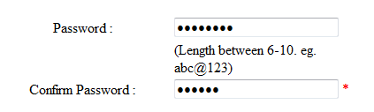

**Code**

<asp:TextBox ID="TextPass" runat="server" Width="180px" TextMode="Password"></asp:TextBox>

<asp:RequiredFieldValidator ID="RequiredFieldValidator9" runat="server"

ControlToValidate="TextPass" ErrorMessage="Enter the Password !"

ForeColor="Red">\*</asp:RequiredFieldValidator>

<asp:RegularExpressionValidator ID="RegularExpressionValidator3" runat="server"

ControlToValidate="TextPass" ErrorMessage="Incorrect Password !"

ForeColor="Red"

ValidationExpression="^.\*(?=.{6,8})(?=.\*[\d])(?=.\*[\W])(?=.\*[\w]).\*$">\*</asp:RegularExpressionValidator>

**Email Validation**



**Code**

<asp:TextBox ID="TextEmail" runat="server" Width="200px"></asp:TextBox>

<asp:RegularExpressionValidator ID="RegularExpressionValidator1" runat="server"

ControlToValidate="TextEmail" ErrorMessage="-mail is not Valid !"

ForeColor="Red"

ValidationExpression="\w+([-+.']\w+)\*@\w+([-.]\w+)\*\.\w+([-.]\w+)\*">\*</asp:RegularExpressionValidator>

**Number Validator**



**Code**

<asp:TextBox ID="TextCont" runat="server" Width="180px"></asp:TextBox>

<asp:RequiredFieldValidator ID="RequiredFieldValidator10" runat="server"

ControlToValidate="TextCont" ErrorMessage="Enter Contact Number first !"

ForeColor="Red">\*</asp:RequiredFieldValidator>

<asp:RegularExpressionValidator ID="RegularExpressionValidator2" runat="server"

ControlToValidate="TextCont" ErrorMessage="Invalid Conctact Number !"

ForeColor="Red" ValidationExpression="\d{10}">\*</asp:RegularExpressionValidator>

**CHAPTER – V**

**TESTING**

**Unit Testing**:

In [computer programming](http://en.wikipedia.org/wiki/Computer_programming), unit testing is a method by which individual units of [source code](http://en.wikipedia.org/wiki/Source_code), sets of one or more computer program modules together with associated control data, usage procedures, and operating procedures are tested to determine if they are fit for use. Intuitively, one can view a unit as the smallest testable part of an application. In [procedural programming](http://en.wikipedia.org/wiki/Procedural_programming), a unit could be an entire module, but it is more commonly an individual function or procedure. In [object-oriented programming](http://en.wikipedia.org/wiki/Object-oriented_programming), a unit is often an entire interface, such as a class, but could be an individual method. Unit tests are short code fragments created by programmers or occasionally by [white box testers](http://en.wikipedia.org/wiki/White-box_testing) during the development process.

**Integration Testing**:

Integration testing is the phase in [software testing](http://en.wikipedia.org/wiki/Software_testing) in which individual software modules are combined and tested as a group. It occurs after [unit testing](http://en.wikipedia.org/wiki/Unit_testing) and before [validation testing](http://en.wikipedia.org/wiki/Verification_and_validation_(software)). Integration testing takes as its input [modules](http://en.wikipedia.org/wiki/Module_(programming)) that have been [unit tested](http://en.wikipedia.org/wiki/Unit_testing), groups them in larger aggregates, applies tests defined in an integration [test plan](http://en.wikipedia.org/wiki/Test_plan) to those aggregates, and delivers as its output the integrated system ready for [system testing](http://en.wikipedia.org/wiki/System_testing). Some different types of integration testing are big bang, [top-down, and bottom-up](http://en.wikipedia.org/wiki/Top-down_and_bottom-up_design).

**System Testing:**

**System testing** is the testing of behavior of a complete and fully integrated software product based on the software requirements specification (SRS) document. In main focus of this testing is to evaluate Business / Functional / End-user requirements. This testing is to be carried out only after System Integration Testing is completed where both [Functional & Non-Functional requirements](http://www.softwaretestingclass.com/) are verified.

From the system testing I assure that my System is secure, robust, portable, flexible and easy to maintain.

For NAAC system I applied the validation to forms such as registration, login, qualification, and so on. Here I consider one form for testing and the test cases are generated for that.

LOGIN FORM DESIGN

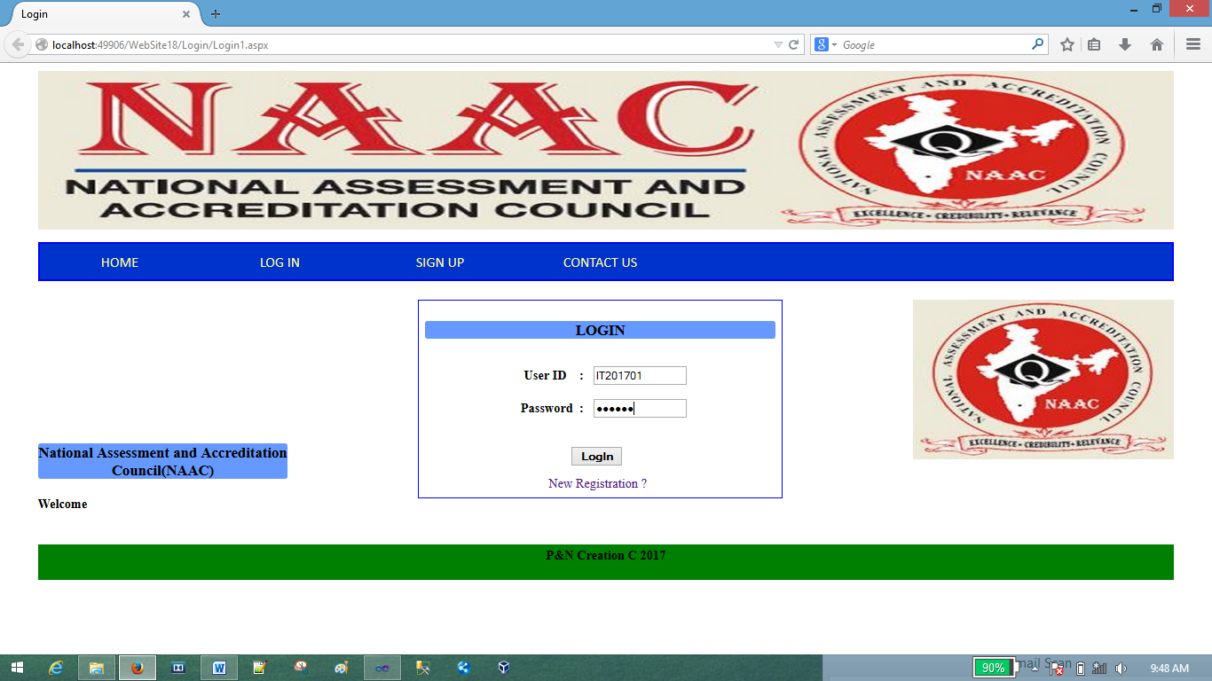

**CODE:**

using System;

using System.Collections.Generic;

using System.Linq;

using System.Web;

using System.Web.UI;

using System.Web.UI.WebControls;

using System.Configuration;

using System.Data;

using System.Data.SqlClient;

public partial class Login1 : System.Web.UI.Page

{

SqlConnection con;

SqlCommand cmd;

SqlDataAdapter da;

SqlDataReader dr;

DataTable dt;

protected void Page\_Load(object sender, EventArgs e)

{

con = new SqlConnection("Data Source=localhost\\sqlexpress;Initial Catalog=NAAC;Integrated Security=True;Pooling=False");

con.Open();

}

protected void Button1\_Click(object sender, EventArgs e)

{

string id = TextBox3.Text;

string password = TextBox4.Text;

cmd = new SqlCommand("select id from Login where id='"+id+"'and password='"+password+"'", con);

da = new SqlDataAdapter(cmd);

dt = new DataTable();

da.Fill(dt);

if (dt.Rows.Count > 0)

{

Session.Add("id", id);

Response.Redirect("../Home/Home.aspx");

}

else

{

Response.Write("<script>alert('User ID or Password is Incorrect !!!');</script>");

}

con.Close();

}

}

**TEST CASE SPECIFICATION**

|  |  |  |  |  |  |  |
| --- | --- | --- | --- | --- | --- | --- |
| **Test No.** | **Test Case Name** | **Test Case Description** | **Procedure** | **Input Data** | **Expected Result** | **Test Result** |
| 1. | User Login | Test the application response when login page is opened | Login form opened at the middle of  The application |  | System should display a login screen with fields:-Username,  Password | PASS |
| 2. | User Login | Test the application response when user clicks on “Login” button | Enter valid Username & Password & click on Login button | Username  Password | System should redirect to the main page successfully | PASS |
| 3. | User Login | Verify the functionality of “Username” field | Enter valid username in  Textbox | Username | System should accept the given data & should not throw any validation errors | PASS |
| 4. | User Login | Verify the functionality of “Password” field | Enter valid password in textbox | Password | System should accept the given data & should not throw any validation errors | PASS |
| 5. | User Login | Test the application response when user Invalid Username & Invalid Password | Enter invalid username & password in textbox | Username  Password | System should display a validation message saying “Invalid username or password” | PASS |
| 6 | User  Login | Test the application response when user Invalid Username & valid Password | Enter invalid username &  valid password in textbox | Username  Password | System should display a validation message saying “Invalid username or password | PASS |
| 7 | User  Login | Test the application response when user invalid Password & valid Username | Enter valid username &  invalid password in textbox | Username  Password | System should display a validation message saying “Invalid username or password | PASS |

**CHAPTER – VI**

**SYSTEM IMPLEMENTATION (DEPLOYMENT)**

**DEPLOYMENT DIAGRAM**

The diagram shows physical layout various hardware component that compose a system as well as the substitution of executable program on this hardware.

**Deployment Diagram For NAAC Reporting System**

**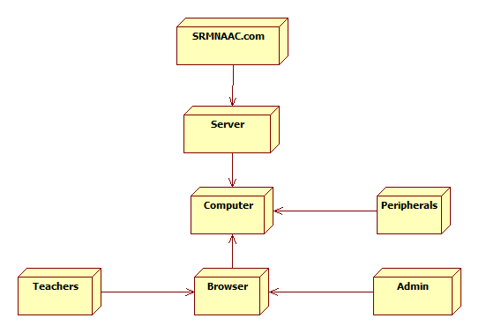**

**System implementation**

We are going to computerize the existing system. The scope of the proposed system is follows.

Teachers are the users of the proposed system.

The information which is required to the NAAC for giving accreditation to the college that all information is inserted managed and maintained by the users of the system without any kind of hard work.

Teachers maintain all the information.

Teachers also maintain the information of the various activities which are not non-educational activities.

Teachers fill the data into system and then system generates result report.

**Step 1-**

First I will check whether computer with peripherals (like mouse, keyboard, printer, etc. minimum) is there or not. If else I will follow 2nd step else I will ask to arrange that.

**Step 2-** I will check the operating system and other required tools are there are not, if yes I will follow 3rd step and if not I will install those required software and tools.

**Step 3-** Then I will install newly developed software named as **“NAAC Reporting System”.**

**Step 4-** Then I will login to that software and I will check forms and menus.

**Step 5-** Then I will give demonstration of the system to the end user (i.e. how to use user manual, how to generate reports, how to add, update, delete info).

**URL**

A URL (Uniform Resource Locator), as the name suggests, provides a way to locate a resource on the [web](http://searchcrm.techtarget.com/definition/World-Wide-Web), the [hypertext](http://searchsoa.techtarget.com/definition/hypertext) system that operates over the [internet](http://searchwindevelopment.techtarget.com/definition/Internet). The URL contains the name of the [protocol](http://searchnetworking.techtarget.com/definition/protocol) to be used to access the resource and a resource name. The first part of a URL identifies what protocol to use. The second part identifies the [IP address](http://searchwindevelopment.techtarget.com/definition/IP-address) or [domain name](http://searchwindevelopment.techtarget.com/definition/domain-name) where the resource is located.

There are many different types of domains, including:

* **.com**: commercial domains, now the largest presence on the Web
* **.org**: organization, can be any type of organization
* **.gov**: government agency, usually federal, but can be state
* **.edu**: educational institution
* **.net**: Internet Service Provider or network

**For NAAC system the URL is** :

Current URL : <http://localhost/NAAC/Login/Home1.aspx>

Proposed URL : <http://www.srmkudal.in/naac/Login/Home1.aspx>

**CHAPTER – VII**

**SYSTEM MAINTENANCE**

**&**

**EVALUATION**

**SYSTEM MAINTENANCE AND FUTURE ENHANCEMENT**

**System Maintenance:**

We are going to computerize the existing system. It is easy to maintain this system.

When the NAAC Committee wants the reports the Admin checks the information in the database if the information is available then he will generate the report and offer to the committee members.

Teachers maintain all the information.

Teachers also maintain the information of the various activities which can be educational or non-educational activities.

Teachers fill the data into system and then Admin can generates report.

**Future enhancement**

1. In future I will try to include other departments (Sports, NCC, NSS, etc) in the system.
2. In future strong security will be provided to system.
3. The fix URL will be implemented in future.
4. We can generate more and accurate report.

**USER MANUAL/ HELP REPORT**

**To access the system we can go through following steps :**

* Following is the general scenario of the system .

**General Scenario**

NAAC

Reporting

System

**HOME**

**SIGN UP**

**LOG IN**

**CONTACT US**

**Brief description of General Scenario :**

* HOME : The home page of NAAC website.
* LOG IN : The log in page to enter in the system.

By providing valid UserID & password you can log in.

* SIGN UP: The registration form to register to system.

UserID is required which is provided by admin to user.

* CONTACT US : Contact details (College contact information).
* If you are admin user then see the Scenario for Admin Login.

**Scenario (Admin LOG IN)**

NAAC

Reporting

System

**HOME**

**TEACHERS DETAILS**

**DEPARTMENT INFORMATION**

**DEPARTMENTS**

**EDIT INFORMATION**

**REPORTS**

**View Course Details**

**View Qualification Details**

**MY PROFILE**

**View Publications**

**View Conference Details**

**View Research Details**

**View Consultancy**

**View Innovations and Patents Details**

**Edit Profile**

**NEW ACCOUNT**

**CONTACT US**

**LOG OUT**

**Brief description of Admin Login Scenario :**

* HOME : The home page of NAAC website.
* DEPARTMENTS : For Admin, departments module shows sub-modules as department information, teacher details, edit information and reports.
* EDIT INFORMATION: This module allow to edit information such as department details, students details, activity details, result details.
* TEACHER DETAILS : Shows all teaching staff from your department.
* REPORTS : Displays reports based on filled information . the reports can be filter with the help of drop down list which shows options (like Academic year, department , etc).
* MY PROFILE : this module is same for all users . The Admin can view their filled information. In edit Profile sub-module, the user can edit their account information or add information such as their qualification, publications, patents, conferences, and so on.
* NEW ACCOUNT : This allow admin to provide UserID for new user(Teacher) to enroll in the system. The UserID generation is automatic , just need to provide correct user name and department name.
* If you are Teacher user then see the scenario for Teacher Login.

**Scenario (Teacher LOG IN)**

NAAC

Reporting

System

**HOME**

**TEACHERS DETAILS**

**DEPARTMENT INFORMATION**

**DEPARTMENTS**

**View Qualification Details**

**MY PROFILE**

**View Course Details**

**View Publications**

**View Research Details**

**View Conference Details**

**View Consultancy**

**Edit Profile**

**View Innovations and Patents Details**

**CONTACT US**

**FEEDBACK**

**LOG OUT**

**Brief description of Admin Login Scenario :**

* HOME : The home page of NAAC website.
* DEPARTMENTS : For Teacher, departments module shows sub-modules as department information, teacher details.
* DEPARTMENT INFORMATION : This sub-module shows the information of departments in college.
* TEACHER DETAILS : Shows all teaching staff from your department.
* MY PROFILE : this module is same for all users . The Teacher can view their filled information.
* EDIT PROFILE : This sub-module, the user can edit their account information or add information such as their qualification, publications, patents, conferences, and so on.
* FEEDBACK : The teacher can place their feedback about system.

**CHAPTER – VIII**

**REFERENCES AND BIBLIOGRAPHY**

**REFERENCES AND BIBLIOGRAPHY**

**Books referred for programming are :-**

1. **Programming in Visual Dot net Studio**

Author :- MacDonald’s.

Anita c. millspaugh.

(TATA McGraw-HILL EDITION)

1. **System analysis and design in a changing world ( SADCW )**

Author :- Sat Zinger.

Jackson and Burd.

(Thompson Learning / Course Technology)

1. **System analysis design and introduction to software engineering**

Author :- Prof. S. Parthasarthy.

Prof. B. W. Khalkar.

1. **Websites**

[**www.srmkudal.co.in**](http://www.srmkudal.co.in)

[**www.google.com**](http://www.google.com)